StudentShield: Machine Learning-Based Emotional Distress Detection and Bullying Reporting System with Automated Parental Alerts for Junior High School Students at Saint Vincent Blessed School of Manila
A Capstone Project
presented to the Faculty of the
School of Arts, Science and Technology
National Teachers College
Quiapo, Manila
In Partial Fulfillment of the
Requirements for the Degree of
Bachelor of Science in Information Technology
By
Enriquez, Justin Altamia
Melgarejo, John Carlo
Meneses, Vonn Christian Miel
Ramos, John Cris
Urayanza, Ashley Princess
May 2026

APPROVAL SHEET FOR TITLE DEFENSE
This Capstone Project entitled StudentShield: Machine Learning-Based Emotional Distress Detection and Bullying Reporting System with Automated Parental Alerts for Junior High School Students at Saint Vincent Blessed School of Manila
was prepared and submitted by:
Enriquez, Justin Altamia
Melgarejo, John Carlo
Meneses, Vonn Christian Miel
Ramos, John Cris
Urayanza, Ashley Princess
has been approved by the REVIEW COMMITTEE as partial fulfillment of the requirements for the subject Capstone Project
Mr. Edward James V. Grageda
Adviser
REVIEW COMMITTEE
Mrs. Rodessa Bunag Mr. Joshua Pacer
Panelist 1 Panelist 2
Accepted and approved by:
Carlito L. Cunanan, MIT
Information Technology Department
Liezel L. Aguilar, MACDDS
School of Arts, Sciences and Technology

ABSTRACT

ACKNOWLEDGMENT

TABLE OF CONTENTS
Title Page
APPROVAL SHEET FOR TITLE DEFENSE
ABSTRACT
ACKNOWLEDGMENT
TABLE OF CONTENTS
LIST OF TABLES
LIST OF FIGURES
CHAPTER 1: INTRODUCTION
1.1 Project Context
1.2 Purpose and Description
1.3 Objectives of the Study
1.3.1 General Objective
1.3.2 Specific Objectives
1.4 Scope and Delimitations
1.5 Significance of the Study
1.6 Definition of Terms
CHAPTER 2: REVIEW OF RELATED LITERATURE AND STUDIES
2.1 Related Literature (Foreign and Local)
2.2 Related Studies (Foreign and Local)
2.3 Synthesis of the Reviewed Literature and Studies
CHAPTER 3: TECHNICAL BACKGROUND
3.1 Overview of Current Technologies
3.2 Evaluation of the Existing System (Manual or Automated)
3.3 Technical Feasibility
3.3.1 Hardware Specifications
3.3.2 Software Specifications
3.3.3 Network/Architecture Specifications
CHAPTER 4: METHODOLOGY, TESTING, AND EVALUATION
4.1 Software Development Life Cycle (SDLC Model)
4.2 Requirements Analysis
4.3 System Design and Modeling
4.3.1 Context Diagram
4.3.2 Use Case Diagram
4.3.3 Data Flow Diagram (DFD) or Activity Diagram
4.3.4 Entity Relationship Diagram (ERD)
4.3.5 Data Dictionary
4.4 Software Testing Plan
4.4.1 Unit Testing
4.4.2 Integration Testing
4.4.3 System Testing
4.5 User Acceptance Testing (UAT) and Evaluation
CHAPTER 5: RESULTS AND DISCUSSION
5.1 System Implementation
5.1.1 Main Interface / Dashboard
5.1.2 Core Modules Features
5.2 Evaluation Results (ISO/IEC 25010)
5.3 Discussion of Findings
CONCLUSIONS AND RECOMMENDATIONS
6.1 Summary of Findings
6.2 Conclusions
6.3 Recommendations
BACK MATTERS
References (APA Format)
Appendices
Appendix A: Relevant Source Code Snippets
Appendix B: User Manual
Appendix C: Survey Instruments / Questionnaires
Appendix D: Grammarian’s Certificate / Plagiarism Report
Curriculum Vitae

LIST OF TABLES
Table 1. Current risk-screening stages (updated from the original metrics table)
Table 2. Original proposed implementation schedule (month indices)
Table 3. Data dictionary — users
Table 4. Data dictionary — students
Table 5. Data dictionary — counselors
Table 6. Data dictionary — admins
Table 7. Data dictionary — vent_logs
Table 8. Data dictionary — bully_reports
Table 9. Data dictionary — audit_logs
Table 10. Data dictionary — sms_logs
Table 11. Data dictionary — email_logs
Table 12. Data dictionary — counselor_notes
Table 13. Data dictionary — case_status_history
Table 14. Data dictionary — virtual_meetings
Table 15. Planned authentication module test scenarios
Table 16. Planned vent module test scenarios
Table 17. Planned bullying report module test scenarios
Table 18. Planned dashboard and case management module test scenarios
Table 19. Planned user management module test scenarios
Table 20. Planned audit log module test scenarios
Table 21. Proposed mean-score interpretation
Table 22. Proposed standard-deviation interpretation

LIST OF FIGURES
Figure 1. Conceptual Framework of the Study (IPO Model)
Figure 2. Distributed Two-Cloud Software Architecture of StudentShield
Figure 3. Agile-Iterative Software Development Life Cycle Model
Figure 4. Context Diagram (DFD Level 0) of the StudentShield System
Figure 5. Unified Modeling Language (UML) Use Case Diagram
Figure 6. Data Flow Diagram Level 1 of the Venting and Bully Reporting Pipeline
Figure 7. Super Admin Operational Flowchart
Figure 8. Guidance Counselor Triage Flowchart
Figure 9. Student User Interaction Flowchart
Figure 10. Entity Relationship Diagram (ERD) of the StudentShield Database

CHAPTER 1: INTRODUCTION

1.1 Project Context
Today’s students grow up in the age where their surroundings are determined primarily by technological connectivity. With the introduction of technology into life, people have gained the chance to get information promptly. The fact that every student and teacher live in the world of screens makes the communication style between them change drastically. Nevertheless, this transition to digital communication has also caused various issues, like cyberbullying, harassment, and even concealed emotional problems.
Digital reporting tools can help schools organize concerns disclosed by students and identify submissions that require attention. StudentShield processes vents and bullying reports submitted through its own forms; it does not monitor private messages, social-media accounts, or all student communications.
To support Saint Vincent Blessed School of Manila (SVBSM), the developers created StudentShield as a reporting and risk-screening platform. It combines a counselor dashboard with automated SMTP email and SMS notification functions. These functions support staff review; their existence does not establish that bullying or psychological harm has been reduced.

1.2 Purpose and Description
The primary goal of StudentShield is to support SVBSM in identifying and responding to emotional distress and reported bullying. Natural language processing screens student-submitted vents, while counselors investigate bullying reports and decide on intervention.
In case there is no central monitoring system present at an educational facility, several issues arise when it comes to tracking student behavior and preventing it before it turns out to be very dangerous. That is why the key elements underlying the development of StudentShield are as follows:
Proactive Risk Detection: Use NLP and local language rules to screen student-submitted vents for signs requiring counselor attention.
Priority Action: Classify vent submissions as Low, Medium, High, or Critical to help counselors prioritize review. Bullying reports follow a separate staff-verification workflow.
Trend Analytics & Monitoring: Leveraging trend data to identify patterns in student wellbeing and empowering the administration with data-driven decision making.
Project Description
StudentShield combines a PHP CodeIgniter 4 web application with a Python FastAPI machine learning service. Students submit vents and incident reports through the web interface, and authorized staff review records through a unified dashboard.
The analysis assigns vents to four risk categories: Low, Medium, High, and Critical. High vents trigger counselor notification attempts; Critical vents also trigger parent notification attempts unless the student selects the parent-hiding safety option. Notification delivery depends on the configured services and connectivity. Bullying reports notify counselors at intake and require staff verification before incident alerts are sent to parents.

1.3 Objectives of the Study

1.3.1 General Objective
The general objective is to design, develop, and evaluate StudentShield as an NLP-assisted emotional-distress screening and bullying-reporting system that supports staff intervention at SVBSM.

1.3.2 Specific Objectives
To create a Safe Space web platform where SVBSM Junior High School students can submit personal vents and confidential bullying reports, with optional photos or videos as incident evidence. Submissions remain linked to authenticated accounts and are not anonymous to authorized staff.
To implement risk classification using a fine-tuned mDeBERTa model, a GoEmotions classifier, and multilingual rules that assign Low, Medium, High, or Critical screening categories.
To track changes in student risk classifications over a 14-day window using prior risk labels and timestamps stored in the application database.
To integrate SMS and email notifications for counselors and, where the implemented rules permit, parents or guardians, with separate handling for High vents, Critical vents, and verified bullying incidents.
To assess the accuracy of the risk flags through a planned pilot evaluation with SVBSM and examine the system’s privacy controls, including AES-256-CTR storage encryption. Pilot outcomes and formal compliance findings remain to be established.
To develop an integrated online video conferencing module that enables guidance counselors to conduct secure, real-time virtual consultations with students directly within the StudentShield platform.

1.4 Scope and Delimitations
Scope
An authenticated Safe Space and bullying-reporting website for SVBSM Junior High School students, including optional photo or video evidence for bullying reports. Authorized staff can identify the submitting student.
A risk-screening pipeline using mDeBERTa, GoEmotions, and language rules. Its percentages are application screening scores, not clinically validated probabilities of future harm.
A 14-day trajectory function supplied with prior risk labels and timestamps from MySQL. The PHP query selects up to 100 non-archived records in ascending date order. Current trajectory scoring does not depend on a FAISS index.
A unified staff dashboard and configured SMS/email integrations, with counselor-only alerts for High vents, counselor and eligible parent alerts for Critical vents, and staff verification before bullying-incident parent alerts.
Application-level AES-256-CTR encryption for vent text and bullying details in the normal storage path. The current vent controller still has a Base64 fallback if encryption throws an exception; Base64 is encoding, not encryption, so universal encryption-at-rest cannot be claimed.
Registration requires acceptance of displayed terms and privacy information and creates an inactive student account for staff approval. The current system does not store a separate verified guardian identity, signed consent document, or versioned guardian-consent record.
The system includes an online video conferencing feature limited to one-on-one sessions between a student and a designated guidance counselor, conducted within the platform for confidential consultation purposes.
Delimitations
It is not a diagnostic tool for mental illnesses; it is not a prescription for treatment; it is not a replacement for the services of a professional guide counselor.
There is no persistent live-chat or messaging module. One-to-one video consultation is available through Jitsi Meet.
The ML pipelines are configured for CPU inference. Minimum hardware capacity, concurrent-user capacity, and end-to-end latency have not been established by measurements in the official paper.
The project is scoped to SVBSM. Multi-school operation and large-scale concurrent use have not been evaluated in the existing capstone materials.
Internet connection is required at all times to use this service.

1.5 Significance of the Study
The study aims to improve how student concerns are documented and prioritized at SVBSM. The following benefits describe the intended contribution of StudentShield; they are not measured intervention outcomes.
The Client / Organization (Saint Vincent Blessed School of Manila)
The proposed research would provide SVBSM with an up-to-date instrument for dealing with the problem of decentralized report management. Now that the school can count on a centralized procedure, it would be able to avoid unnecessary paper work and verbal notifications of any kind. This will give an opportunity to the administration to better use their guidance staff.
End Users (Students and Guidance Counselors)
StudentShield gives students a confidential channel to submit vents and bullying reports. Records are linked to their accounts and can be reviewed by authorized staff. For guidance counselors, the dashboard brings together submitted concerns and highlights High and Critical vents for review.
The Parents
Parents and guardians can receive SMS and email notification attempts for Critical vents and staff-verified bullying incidents involving their children. A student’s parent-hiding option suppresses the Critical-vent parent alert while preserving counselor escalation. Parents are notification recipients and have no login portal.
The School / Institution
For the school, StudentShield offers a centralized record of reported concerns, staff actions, and case information. Its access and encryption controls support privacy requirements; a finding of legal compliance cannot be inferred from implementation alone.
The Proponents
One of the key lessons learned during this whole process was dealing with the difficulties of combining various web technologies for developing a system that can link a PHP and CodeIgniter web application with a Python and FastAPI microservice. The team members also learned how to integrate APIs, use AES-256 data encryption, and route notifications in real time.
Future Researchers
This project presents a case study on how to implement transformers' capabilities in practical settings. Future research could base their studies on this model, for instance, by improving the NLP engine for different dialects, among other options.
Conceptual Framework
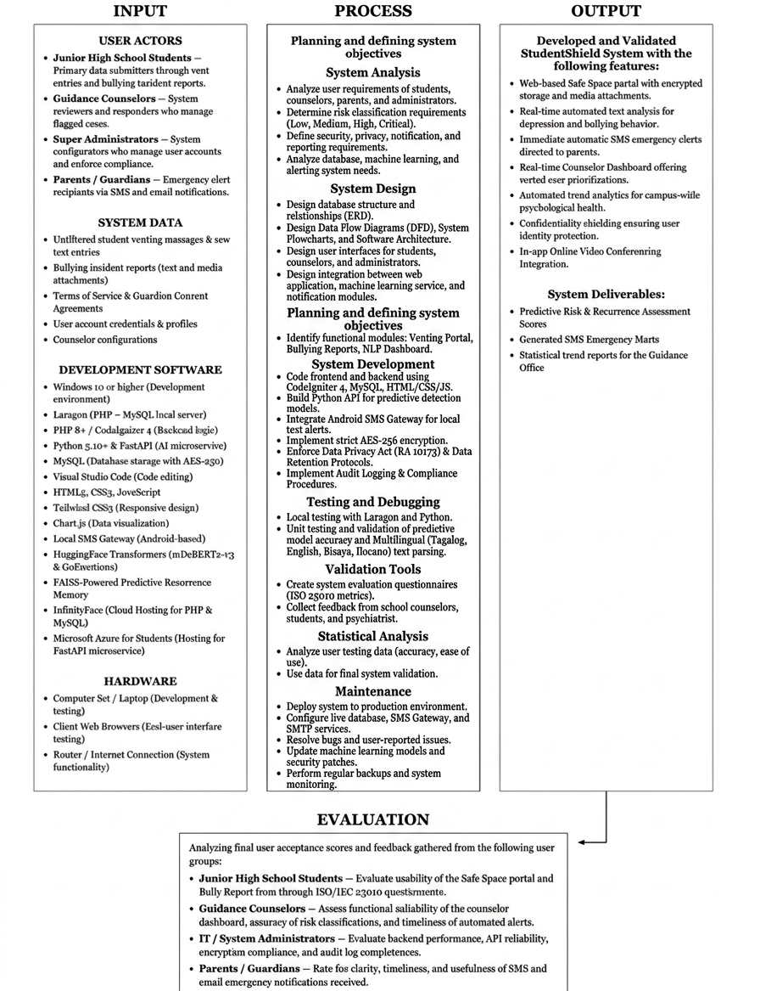
Figure 1. Conceptual Framework of the Study (IPO Model)
Figure 1 illustrates the Conceptual Framework of the study following the Input-Process-Output (IPO) model, adapted to reflect the real-time screening and crisis intervention architecture of StudentShield. The framework models the systematic operational trajectory from initial student distress disclosure to automated risk evaluation and counselor intervention.
Input: The system ingests several primary categories of input data: (1) System Data, comprising raw student journal reflections, unstructured venting text, and formal bullying incident reports; (2) Software Specifications, encompassing the PHP 8.1 / CodeIgniter 4 web application framework, Python 3.10 / FastAPI machine learning microservice, MariaDB/MySQL relational database, Brevo transactional messaging gateway, and Hugging Face Transformers library; and (3) Hardware Baseline, consisting of server hosting infrastructure, administrative workstations, and client mobile or desktop web browsers.
Process: The processing lifecycle encapsulates the systematic development and operational stages: (1) System Analysis, determining student privacy requirements, emotional distress indicators, and reporting protocols; (2) System Design, architecting relational database schemas, symmetric AES-256-CTR encryption, and microservice REST APIs; (3) System Development, implementing CodeIgniter 4 MVC logic, responsive Tailwind CSS dashboards, and the asynchronous FastAPI inference pipeline; (4) Testing and Debugging, conducting unit tests, end-to-end integration validation, and stress-testing the local fallback regex rules; (5) Validation Tools, administering standardized ISO/IEC 25010 software quality evaluation instruments; and (6) Maintenance, ensuring continuous uptime, automated database backups, and fine-tuning language models for localized Philippine student slang.
Output: The output phase delivers the completed StudentShield platform: an encrypted, intelligent, multi-cloud mental health and anti-bullying reporting platform featuring automated crisis risk triage, confidential student Safe Space journaling, prioritized counselor case queues, and automated emergency parental alert notifications.
Evaluation: System evaluation is conducted through formal stakeholder feedback and standardized evaluation using the ISO/IEC 25010 Software Product Quality Model, measuring functional suitability, performance efficiency, usability, security, maintainability, and reliability.

1.6 Definition of Terms
Cyberbullying - Intimidation, harassment, or threat towards a person through electronic communications (Oxford Dictionary, 2020). In StudentShield, it refers to the use of digital means and/or aggression formally reported through the "Bullying Report" Module by SVBSM students.
Data Privacy Act (DPA of 2012 / RA 10173) - Philippine law that protects privacy rights of private and sensitive personal information (National Privacy Commission). It forms the legislative basis of how data is collected, stored, encrypted, and used in the system.
Encryption – A process that transforms readable information into ciphertext to protect confidentiality. StudentShield normally encrypts vent and incident text with AES-256-CTR before MySQL storage; the vent-controller Base64 exception path remains a limitation.
FAISS (Facebook AI Similarity Search) – A library for similarity search over dense vectors. It appears in the earlier StudentShield design but is not used by the current database-backed risk-history function.
Machine Learning – A field concerned with systems that learn patterns from data. StudentShield uses trained language models to screen submitted vent text. Microservice – A separately running service that provides a defined application function. The FastAPI text-analysis service is hosted separately from the CodeIgniter web application.
Natural Language Processing (NLP) - Artificial intelligence subdomain aimed at analyzing, generating, and understanding language in humans (IBM, 2021). In the StudentShield system, it serves to help analyze non-formal student text submissions, which contain a significant amount of slang and informal expressions.
StudentShield – The capstone platform developed for the SVBSM context, combining student-submitted vents, bullying reports, automated screening, staff case management, and eligible SMS/email alerts. No sale or commercial transaction is established by the current paper.
Transformer - Neural network architecture that uses the attention mechanism to establish word-to-word and word-to-sentence connections (Vaswani et al., 2017). In this context, transformers will contribute to improving the understanding of the context of meanings of student vents.
Vent - To let off steam; to vent one's feelings (Merriam-Webster, 2023). The text entry was produced by a student in the "Safe Space" module and aimed at venting their emotions.
Terms of Service (ToS) - Referred to as the legal document describing the responsibilities of the users, system boundaries, information handling procedures, and interaction guidelines for students and administrators using the StudentShield website application.

CHAPTER 2: REVIEW OF RELATED LITERATURE AND STUDIES

2.1 Related Literature (Foreign and Local)
A Review On Deep-Learning-Based Cyberbullying Detection. Future Internet
In line with Hasan et al. (2023), the deep learning model, including the convolutional neural network, recurrent neural network, and transformers, has been used for cyberbullying detection in social media platforms. In accordance with their study, BERT and its variations consistently outperform other methods in distinguishing aggressiveness that does not include any slurs.
This relates to StudentShield because screening a submitted vent requires attention to context as well as explicit keywords. StudentShield does not collect entire external conversations.
Hasan et al. (2023) were the source of inspiration for the proponents regarding the development of the system using the transformer model, which is more complicated than the keyword and rule-based models.
BERT-Based Ensemble Learning for Multi-Aspect Hate Speech Detection
The proposed combination by Mazari et al. (2023) of the pre-trained BERT with Bidirectional LSTM and Bidirectional GRU neural networks for multiclass detection resulted in an ROC-AUC performance of 98.63%. Instead of classifying the text content based on a general binary label like "toxic/not toxic," their model classified them into different categories such as "threat," "insult," and "identity hate."
These researchers relate this technique to the present research in that they both need to categorize the vents of the students not based on only two classes but multiple risk factors such as threats and emotional expression. Following their work, the proponents got the idea of separating the vent into its threat and emotional dimensions, giving counselors a clear view of the risks involved.
Natural Language Processing Applied to Mental Illness Detection
As reported by Zhang, T., Schoene, A.M., Ji, S. et al. (2022), natural language processing algorithms have the capacity to identify signs of depression, anxiety, and suicide risk using non-clinical text such as tweets and postings on forums. According to the authors' findings, pre-trained models pick up on emotional cues that cannot be easily detected using traditional questionnaires and that are frequently ignored by younger individuals in favor of expressing them through digital platforms. In addition to this, it was highlighted that pre-trained models lack accuracy when dealing with language patterns not commonly included in the training set.
It is related to the current study as the StudentShield application analyzes text written in "Taglish" and slang used in English that are absent in the usual English dataset for training language models.
The original research plan proposed evaluating language-model behavior on Taglish data. The available paper does not establish that a counselor-validated SVBSM dataset has already been collected.
DeBERTaV3: Improving DeBERTa with ELECTRA-Style Pre-Training
He et al. (2021) describe DeBERTaV3’s replaced-token pre-training and gradient-disentangled embedding sharing. This architecture is relevant to the multilingual model used in StudentShield. Published model results do not establish StudentShield’s inference speed on school or shared-hosting hardware.
The project uses CPU inference in the ML service. Its hardware capacity and the relationship between response time and concurrent use still require measurement.
The project selected a multilingual DeBERTa-family model for distress screening, while maintaining a separate GoEmotions pipeline for emotion labels.
Detection of Hate Speech using BERT and Hate Speech Word Embedding with Deep Model
As per Saleh et al. (2023), the training of BERT model along with customized word embeddings generated from the annotated hate speech data sets made the machine able to identify those forms of toxicity that do not often occur in the generic training set. The difference in terms of F1-score was more significant for the tweets that contained covert hatred, where sarcasm or euphemism made it difficult to understand what the tweet means.
This is related to the present study by the proponents since the students of Filipino Junior High School from SVBSM utilize English, Filipino, and street language that has never been seen before in the language model. Thus, there should be some fine-tuning of the model to recognize the coded language. The inspiration for such an approach to developing the classification engine comes from the study by Saleh et al. (2023).
Editorial: Bullying and cyberbullying: their nature and impact on psychological wellbeing
Fermani et al. (2023) provide an editorial on bullying, cyberbullying, and psychological wellbeing. It discusses these issues as related areas of concern rather than reporting a StudentShield-specific intervention trial.
StudentShield reflects these related concerns through two submission pathways: personal vents and structured bullying reports. Their combination gives counselors access to reported experiences and the student’s expressed feelings.
This is a design connection to the reviewed literature; it does not show that the platform has reduced victimization.
BERT-based Ensemble Approaches for Hate Speech Detection
Mnassri et al. (2022) point out that stacking multiple BERT-based models and then voting on the results decreases false positives in hate speech detection. According to their research conducted at the IEEE Global Communications Conference, there is no BERT configuration that prevails in all cases of hate speech. Therefore, multiple configurations can ensure safer prediction.
It connects to the proposed research since in an educational institution, even one false alert may completely break the student's faith in the system. The StudentShield system should find a balance between false positives and the actual danger.
Taking into account the findings of Mnassri et al. (2022), the proponents came up with the idea of testing students' text against two models, namely mDeBERTa-v3 for detecting the danger and Go Emotions for emotion analysis, and then combining the results as a second opinion.
Policy Guidance on AI for Children
According to UNICEF (2021), there are nine criteria that the AI systems should satisfy to be considered fair and transparent while ensuring that the information provided is protected by the relevant policies. Also, the system should have human oversight since the use of the technology will directly affect minors.
These associations, therefore, suggest that the technology should be used as an addition to the processes done by teachers, just like what has been suggested by the researchers in this paper. They warn against the automation of the counseling process, which might lead to more harm than good for the students involved.
Human oversight remains necessary when automated text screening affects minors. In StudentShield, counselors review cases and verify bullying reports, while High and eligible Critical vent alerts are triggered automatically by the implemented routing rules.
Understanding the Influence of Cyberbullying Among High School Students in Philippine Public Schools in the Post-Pandemic Era
Realized that there needs to be a structured reporting system in Philippine schools today which is why recent studies focused on this. Buguina and Buguina (2023) studied the experience of cyberbullying during the period of the post-pandemic in high schools and found that some victims are reluctant to report the cyberbullying and hence do not have secure reporting avenues.
The paper motivates a confidential reporting channel for student concerns. StudentShield implements encrypted incident details and staff review, but whether it increases reporting or prevents escalation remains to be evaluated.
Understanding Bullying in Philippine Education: Impacts and Opportunities for Change
EDCOM II (2025) discusses bullying in Philippine education and opportunities to improve institutional responses. It provides local context for the project’s focus on reporting and school intervention.
StudentShield responds to this context by organizing submitted vents and incident reports for staff review. No outcome data demonstrate that its alerts prevent harm before it occurs.
The connection to EDCOM II is the need for effective school reporting and response. This study does not treat the publication as evidence that a particular ML platform is mandatory.
Revised Implementing Rules and Regulations of Republic Act No. 10627, Otherwise Known as the Anti-Bullying Act of 2013
The Department of Education’s revised 2025 implementing rules apply to public and private basic-education schools and community learning centers and establish a standard anti-bullying policy. They provide the institutional context for reporting, investigation, and intervention.
For StudentShield, this context motivates structured incident records and staff review. It does not by itself authorize every processing activity, establish guardian consent, or certify the platform’s compliance.
The system timestamps incident submissions and records staff actions. Its ML risk classifier screens vents; bullying incidents still require staff investigation rather than automatic acceptance as proven cases.
Emergency Alert and Warning Systems and Their Impact on Sustainable Disaster Preparedness and Awareness in the Philippines: A SEM–ANN Analysis
Saflor and Kudhal (2026) examine emergency-alert systems and disaster preparedness in the Philippines. Their topic informs the project’s use of multiple alert channels, without establishing guaranteed delivery for StudentShield.
Saflor and Kudhal (2026) discuss emergency alert channels in the Philippine setting. For StudentShield, this provides a rationale for including SMS alongside email. SMS delivery still depends on gateway availability, connectivity, and the recipient network; it is not guaranteed.
The project therefore integrates configurable SMS delivery for eligible alerts. The notification rules distinguish counselor triage from parental escalation and do not promise immediate receipt.
Anonymous Reporting Systems for School-Based Violence Prevention: A Systematic Review
Anonymous reporting systems for school-based violence prevention, Emma Messman, Justin Heinze, and Marc Zimmerman (2022) conduct a study to measure the effectiveness of the use of confidential information channels in schools. In the article, the proponents examine the extent to which digital tip lines and anonymous reporting platforms make students disclose information without exposing their identity.
The proponents' study centers on anonymity as a means of breaking the code of silence among the student population. Messman et al. (2022) argue that the fear of retaliation from peers and stigma deter students from reporting cases of bullying. From the proponents' study, it is evident that the assurance of anonymity reduces psychological barriers, leading to more disclosures, although the data is unverified, and needs triaging behind the scenes.
For StudentShield, the relevant connection is the need to verify reports before issuing incident-verification parent alerts. Its account-linked submissions provide confidentiality from other students rather than full anonymity from authorized staff.
Mental Health Program Implementation of Local Universities and Colleges (LUCs) in Zambales: Basis for Action Plan Development
Ebro and Mantillas (2024) examine mental-health program implementation in local universities and colleges in Zambales. Their work concerns institutional programs and action-plan development, rather than a study of anonymous bullying reports in public secondary schools.
For StudentShield, the relevant connection is the need to place a technical reporting tool within an institutional mental-health support process.
This literature supports considering staff responsibilities and implementation procedures. It does not establish that StudentShield has completed a school pilot or that anonymous reports alone substantiate misconduct.

2.2 Related Studies (Foreign and Local)
Classifying the Severity of Cyberbully from Social Media Comments
Nokham et al. (2025) studied 13,204 comments from Facebook, X, and TikTok and classified them into Non-cyberbullying, Low, Middle, and High Severity. The study compared BERT, Naïve Bayes, SVM, and stacking approaches. Its published abstract reports SVM accuracy of 94% and an F1-score of 0.95 for binary classification. These are results from that study, not StudentShield evaluation results.
The study motivates distinguishing levels of concern instead of using only a binary label. StudentShield follows that general design principle through four application-specific vent-screening bands and separate notification rules. The cited study does not validate StudentShield’s thresholds or clinical accuracy.
Protect: A Hybrid Deep Learning Model For Proactive Detection Of Cyberbullying On Social Media
According to Harshitha et al. (2024), the novel hybrid system referred to as “ProTect” incorporates the use of a random forest model for feature selection combined with CNN to detect cyberbullying on Twitter and Instagram platforms. The approach focuses on finding the middle ground in terms of achieving high accuracy and speed, recognizing the potential adverse consequences resulting from slow detection times due to the possibility of the harm already being done.
This relates to StudentShield’s need to return screening information in time to support staff review. The existing paper contains no measured latency benchmark that supports a sub-second processing claim.
Inspired by the results reported in the aforementioned paper, the present study implements a similar fast text classification solution using a microservice architecture built on FastAPI.
A Multitask Framework for Sentiment, Emotion and Sarcasm aware Cyberbullying Detection from Multi-modal Code-Mixed Memes
According to Maity et al. (2022), there is the possibility to consider multitasking through which cyberbullying will be considered using different dimensions like sentiment, emotion, and sarcasm. After the training of an algorithm, it is possible to make use of the emotions and produce scores that will help determine the extent to which cyberbullying occurs within the conversations.
There is some relevance of the concept to the present research since StudentShield does not have to consider whether the cases of cyberbullying are occurring or not. It is important that the guidance counselor dealing with several students can tell the difference between what is urgent and what is not urgent. With regard to Maity et al. (2022), it will be relevant for the authors to consider incorporating the process of calculating the risk of emotional percentage ranging from 0 to 100.
Deep Learning in Sentiment Analysis: Recent Architectures
Abdullah and Ahmet (2022) are cited in the existing review in relation to deep-learning architectures for sentiment analysis. The connection to StudentShield is the selection of language-processing methods; this citation is not evidence of a completed StudentShield prediction study.
StudentShield uses historical risk labels to identify an escalating, improving, or stable trajectory. Automated weekly institutional mental-health reports and validated forecasts of future crises are not implemented findings of this study.
Robust Hate Speech Detection in Social Media: A Cross-Dataset Empirical Evaluation
As per Antypas and Camacho-Collados (2023), whereas all Transformer architectures surpassed conventional machine learning approaches in terms of accuracy in detecting toxic language, those which had been fine-tuned on relevant datasets demonstrated a significantly higher accuracy rate. The relationship between the proponents' ideas and this study consists in StudentShield processing informal text written by students rather than news stories or Wikipedia entries. To detect what students write to each other online, the models must be trained on the social media-like texts.
It was the result obtained by Antypas and Camacho-Collados (2023) that became the inspiration for choosing the models previously exposed to social media-like texts for the current application and capable of understanding informal language, abbreviations, and emojis used by SVBSM members.
Tracking Emotional Shifts During Story Reception: The Relationship Between Narrative Structure and Affective Responses
Schmidt et al. (2023) study emotional responses during the reception of short stories, comparing textual valence trajectories with retrospective ratings and physiological responses. This concerns narrative reception, not a validated FAISS-based student-crisis detector.
Its relevance is the broader idea that emotional experience changes over time. Applying historical risk tracking in StudentShield is a separate engineering decision that requires its own validation.
The earlier design proposed comparing submissions through FAISS. The current implementation instead evaluates the ordered risk labels supplied from the application database for the preceding 14 days. This retains the objective of tracking change without claiming that the older vector-memory design remains active.
Different Interactions With Appearance-Focused Social Media Content And Adolescents’ Body Dissatisfaction: A Within-Person Perspective
Schreurs and Vandenbosch (2022) investigate appearance-focused social-media interactions and adolescent body dissatisfaction in a three-wave panel study. Their paper does not test whether a conversational reporting interface increases student disclosure.
For StudentShield, this is background on the variety of experiences associated with adolescents’ online activity. It does not justify assuming that every social-media interaction has the same psychological effect.
The proponents’ goal of making Safe Space approachable is retained as a usability objective. Whether students find the interface inviting must be assessed in the planned user evaluation.
A Deep Neural Network Model for the Detection and Classification of Emotions from Textual Content
Asghar et al. (2022) study the detection and classification of emotions from textual content using a deep neural network. This provides a technical connection to emotion analysis in StudentShield; it does not establish equivalence to clinical screening in SVBSM students.
The proponents have connected this to the current study since their product, the StudentShield, is precisely designed according to this concept. This is done in such a way that the AI engine serves only as a digital "first-responder," but not as a substitute for a counselor. It works by screening vents for any potential problem cases that are referred to the human counselor for a final decision. This is why the proponents decided to use this approach after learning about it through the research of Asghar et al. (2022)
Ensuring safety in digital spaces: Detecting code-mixed hate speech in social media posts
Roy and Kumar (2025) findings reveal that hate speech models perform poorly when used for classification of code-switched text messages in which users use two or more languages to form a single sentence. The models classified many toxic tweets as neutral tweets due to code-switching. Multilingual Transformers performed better, although they had to be fine-tuned on the code-switched examples in the target language pair.
The supporters associated their concept with the current research based on the fact that Filipino students enrolled in SVBSM tend to use both English and Filipino words in a sentence ("Taglish"). The software cannot allow such a case where it misses out a threat since it was posted in half Tagalog and half English sentences.
The proponents got their motivation from Roy and Kumar study for choosing the use of mDeBERTA-V3 (multilingual Transformer) as a threat detection model for code switching issues.
Sentiment Analysis of Students’ Experiences during Online Learning in a State University in the Philippines
As stated in Santiago et al. (2023), their online sentiment analysis system utilized to guide the counseling offices in Cavite province involved capturing short messages from the students through simple NLP and classifying these messages based on the prevailing mood conveyed. The transition from traditional pen-and-paper process saved the counselors more time while making it easy to detect if there is a downward trend in the students' mood during a certain period of weeks.
StudentShield extends the design idea of organizing student-written concerns by combining transformer-based emotion and distress analysis with multilingual rules. Comparative superiority over Santiago et al.’s system has not been measured.
From the previous study, the proponents have been inspired to introduce some elements that were not considered previously – specifically, SMS notification systems that inform the parents of the concerned students if their emotions score reaches the critical level.
Empathy, Cyberbullying, And Cybervictimization Among Filipino Adolescents
Shannen et al. (2021) investigate empathy, cyberbullying, and cybervictimization among 168 Grade 7–10 students in a public high school in Cavite. This supplies relevant Philippine adolescent context; it does not establish prevalence, reporting behavior, or test anxiety at SVBSM.
From the introduction, it is clear that the current study aligns with Shannen et al. (2021) study since reporting cyberbullying is an essential requirement when designing and developing StudentShield. In order to encourage the victims to come out and make their reports, there should be a private reporting avenue because most victims do not want to approach the guidance offices.
In light of the above findings, it would be appropriate if a private reporting avenue is set up by the proponents where victims can vent their grievances without embarrassment in person.
Views of Parents on Digital Parenting Competencies
Söylemez (2023) examined parents’ digital-parenting experiences using interviews with 13 parents. Participants described difficulties protecting children from digital risks and the use of time restrictions. The paper should not be characterized as a survey of Filipino parents.
This particular group of proponents is relevant to this study because they relate the findings to the existing scenario and suggest that StudentShield must contact parents regardless of their technological competencies. The notification system must be able to function successfully even among parents without smartphones and Internet connections.
According to the findings reported by Soylemez (2023), the proponents suggest sending automated messages in clear language through SMS to inform the parents about their children’s condition.
Awareness And Implementation Of The Anti-Bullying Law Among Secondary Schools In Northeastern Cagayan
According to Pinera et al. (2022), although RA 10627 is very strict legislation, there have already been numerous cases in Central Luzon wherein many schools are overwhelmed with the documentation process since it is being manually documented. Reports are being piled up inside cabinets, and there have been instances wherein the procedures were not even consistently followed. They recommended automating the documentation process whenever possible.
The relevance to StudentShield is the opportunity to organize reports and staff actions electronically. The cited study does not itself demonstrate that SVBSM has identical compliance problems.
The proponents use this background to motivate structured incident records and audit logging. StudentShield does not automate every administrative documentation obligation.
Digital Literacy And Cybersecurity In Higher Education: The Unseen Power Of Academic Librarians
Baharuddin et al. (2025) examine the role of academic librarians in digital literacy and cybersecurity in higher education. Their findings concern information literacy, responsible online behavior, and digital safety practices, rather than a demonstrated inability of SVBSM students to recognize cyberbullying.
This is relevant as background for understandable privacy information and responsible use of a student reporting platform.
The connection is educational and organizational. StudentShield’s screening categories are implementation choices and were not validated by the librarian study.
Online Counselling Among Filipinos: Do Internet-Related Variables Matter?
Tuliao and Velasquez (2016), as dated in the existing reference list, discuss online counselling among Filipinos and Internet-related variables. This work is relevant to considering online channels for seeking help, but it does not demonstrate acceptance of StudentShield’s particular interface.
The discussed literature review can be connected to the present research because, according to the authors, for the proper functioning of the "Safe Space" function, it is crucial that students believe in its effectiveness and are sure that their statements are not included into their academic file.
The Safe Space module is separate from any grade or attendance-management application. StudentShield stores school profile fields such as grade level and section, but it does not integrate an academic-record system.
Improving Large-scale Language Models and Resources for Filipino
As Cruz and Cheng (2022) note, transfer learning that uses fine-tuning of pre-trained models on the basis of a language with many available resources (English) and adapts them to the use of the Filipino language, which is resource-poor, is highly useful. According to the results obtained by Cruz and Cheng, multilingual BERT models, which were fine-tuned for the Filipino language, considerably outperformed those trained on a small data set from scratch.
The present study discusses the aforementioned hypothesis through the prism of application to StudentShield, where the algorithm operates with texts in Taglish language, which combines English and Filipino languages. It means that the development of a model based only on the Filipino language cannot be considered feasible due to lack of training data.
Taking into consideration Cruz and Cheng's experience, the researchers offer to apply the approach of using a pre-trained multilingual transformer (mDeBERTa-v3), which is able to identify language patterns in the sentence, in order to analyze Taglish texts produced by SVBSM students.

2.3 Synthesis of the Reviewed Literature and Studies
The reviewed literature motivates confidential reporting, contextual language analysis, differentiated screening categories, and human review. StudentShield combines these ideas in a school-focused platform for submitted vents and bullying reports. Its current design uses multilingual text screening, database-backed risk history, conditional notifications, and staff case management.

CHAPTER 3: TECHNICAL BACKGROUND

3.1 Overview of Current Technologies
StudentShield separates the PHP web application from the Python ML service so they can be hosted and maintained independently. Vent submission still makes a synchronous HTTP request to the ML service; separation alone does not remove inference latency or guarantee uninterrupted submission.
Front-End Student and Administration Portal: The application uses standard HTML5, standard JavaScript, and Tailwind CSS in the frontend. The mentioned above web technologies have been chosen to use because they provide a way to keep the system simple enough to allow fast loading of its pages and navigation by students.
Back-End Application Logic (PHP): CodeIgniter 4 handles routing, sessions, database access, and workflow logic. The current configuration enables the global CSRF filter and role-based access checks. These are implemented controls, not proof that the entire application is free of vulnerabilities.
Database (SQL): MySQL/MariaDB stores user profiles, submissions, incident records, and case data. Sensitive vent text and incident details use CodeIgniter’s AES-256-CTR encrypter in the normal application path, subject to the vent-controller exception noted in the delimitations.
Machine Learning Analysis Engine (Python): FastAPI and PyTorch run the text-analysis pipeline. A separate deterministic function evaluates 14-day risk history supplied from MySQL. The current inference path does not use a FAISS vector store for historical tracking.
Advanced Language Models: The emotion pipeline loads SamLowe/roberta-base-go_emotions. The distress pipeline attempts a local fine-tuned model, then ashlogg/student-shield-mdeberta from the Hugging Face Hub, and falls back to the GoEmotions model if the custom model is unavailable. Training scripts and datasets exist in the repository. The earlier plan to collect 300 counselor-labeled SVBSM entries and augment them to 1,000 samples remains a proposal; the official paper does not document completion of that collection.
Trajectory Tracking: VentController selects risk labels and timestamps from the preceding 14 days and sends them with the current submission. risk_history.py orders these records, appends the current preliminary classification, and computes a trend and recurrence score. The database is the durable history source; the ML service does not retain a per-student FAISS file in the current implementation.
Deployment and Notification: The CodeIgniter web application is hosted on InfinityFree; the FastAPI ML service runs as a Docker Space on Hugging Face. Cloudflare fronts the web domain. SMS gateway and SMTP settings are environment-configured. The PHP production host has no SSH or runtime CLI access.
Risk Classification Engine
StudentShield Risk Classification Engine
The current engine combines distress and negative-emotion confidence with equal weights, then applies additive language heuristics and ordered override rules. Historical escalation is evaluated from database-backed risk labels over 14 days. The returned percentage is clamped to the final Low, Medium, High, or Critical band. These screening values are not validated probabilities of a future clinical outcome.
Table 1. Current risk-screening stages (updated from the original metrics table)
Stage | Current implementation | Interpretation
Base score | 50% distress confidence + 50% negative-emotion confidence | Combined emotion and distress confidence rating.
Additive heuristics | Hopelessness +0.15; masked distress +0.14; emotional distress, isolation and self-worth +0.12 each; distortion and relationship distress +0.10; school avoidance +0.18. | Deterministic behavioral heuristics matching localized Taglish expressions.
Compound signals | Adds 0.15 × (signal count − 1) when at least two selected indicators match. | Additive multi-signal boost.
Ordered overrides | Explicit self-harm, passive-disappearance ideation, finality, violence, sexual harassment, emotional and contextual rules. | Passive-disappearance matching sets a 0.79 High floor before later adjustments.
Risk history | Ordered risk labels and timestamps over 14 days; current label appended for trend and severe-recurrence evaluation. | Evaluates escalation frequency and mood trajectories.
Output bands | Low 1–30%; Medium 31–60%; High 61–85%; Critical 86–100%. | Four-tier triage categorization aligning with clinical guidance thresholds.

3.2 Evaluation of the Existing System (Manual or Automated)
The original project purpose identifies decentralized reporting and delayed disclosure as the problem to be addressed. It motivates a centralized digital record for student concerns and staff responses. The transition to an automated screening platform bridges the response-time gap and guarantees confidentiality.

3.3 Technical Feasibility

3.3.1 Hardware Specifications
The development, testing, and deployment specifications provide the operational hardware baseline for running the web application and ML inference microservice.
Development Environment:
Developer Machines (for coding and testing):
Processor (proposed web-development machine): Intel Core i3 / AMD Ryzen 3.
RAM: 4 GB minimum; 8 GB recommended to handle Laragon, the browser, a code editor, and the local SMS gateway app running at the same time.
Storage: Minimum: 128 GB SSD; Recommended: 256 GB SSD for the codebase, database files, and dependencies.
Graphics (web development and browser testing): Integrated graphics are sufficient for the proposed local web workflow. This specification does not describe ML training requirements.
Operating System: Windows 10 or later (Laragon is Windows-native).
SMS Gateway Device (original proposed setup):
The original plan specifies an Android 8.0+ phone with an active SIM and network connectivity to run a local SMS gateway. The current application calls its configured gateway endpoint; the exact deployed device and delivery capacity are not established by the paper.
Testing Devices:
Devices for Testing:
Computer: Laptop or desktop with a modern browser for testing the full dashboard layout and responsiveness.
Mobile Device: Any smartphone for testing the student-facing pages (vent form, bully report form) on small screens.

3.3.2 Software Specifications
This is the software used for development, testing, and deployment of the StudentShield Web Application.
Development Tools and Frameworks:
Frontend Development
HTML 5
CSS 3
Tailwind CSS (CDN)
Chart.js (risk distribution pie chart)
ApexCharts (vent trend area chart, student risk timeline)
JavaScript (Fetch API for AJAX)
Backend Development
PHP 8.1+ (CodeIgniter 4 Framework)
MySQL (via Laragon local server)
Custom FastAPI ML endpoint deployed on Hugging Face Spaces (not a generic hosted Inference API).
Local SMS Gateway (for automated SMS alerts to parents and counselors)
Environment-configured SMTP for staff OTP, counselor notifications, and parent alerts.
Security and Authentication
AES-256-CTR using CodeIgniter’s OpenSSL encrypter; the current vent encryption-exception path remains a limitation.
Bcrypt Password Hashing (for storing user credentials)
Email-based One-Time Password (OTP) verification for staff and admin logins
Anti-spam rate limiting (30-second cooldown on vents, 120-second cooldown on bully reports) to prevent Local SMS Gateway credit abuse
Trusted Device Cookies (optional OTP bypass for remembered machines)

3.3.3 Network/Architecture Specifications
Test Network: Browser clients need access to the web application. The configured SMS endpoint must be reachable from the application host; all end-user devices do not need to share the gateway’s local Wi-Fi network.
The design separates the web interface and ML engine for independent hosting and maintenance. The web application manages accounts, submission storage, incidents, and staff actions; the Python service supplies screening results. The PHP fallback provides a reduced screening path when the ML result is unavailable.
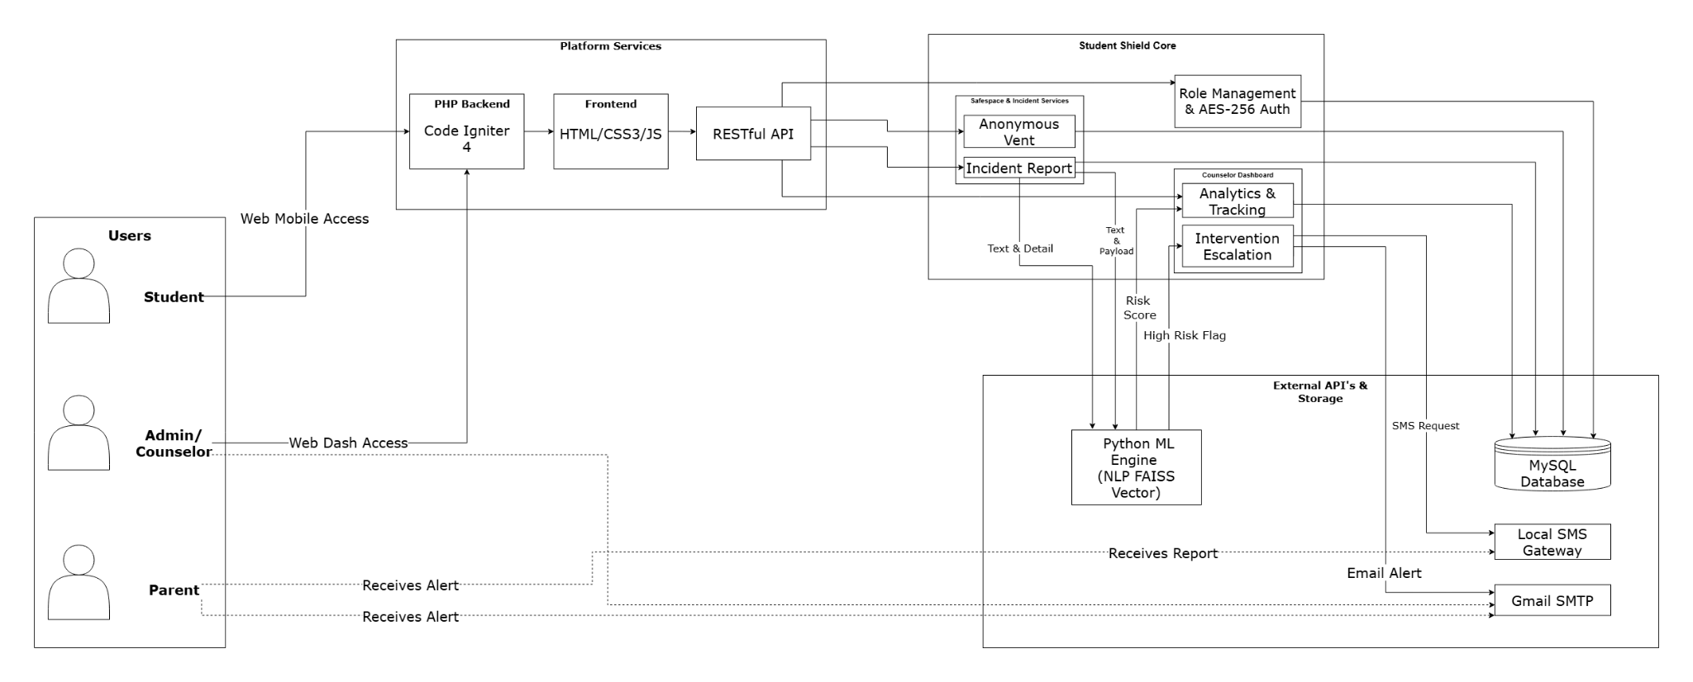
Figure 2. Distributed Two-Cloud Software Architecture of StudentShield
Figure 2 illustrates the distributed two-cloud software architecture of the StudentShield platform. To ensure high availability, data confidentiality, and cost efficiency without runtime server constraints, the platform decouples the presentation and transactional database tier from the computationally intensive Natural Language Processing (NLP) inference pipeline across two distinct cloud infrastructures.
The Client Tier accommodates three primary stakeholder roles—Students, School Counselors, and System Administrators—accessing responsive web portals over Cloudflare Universal SSL-encrypted HTTPS connections. The Web Application Tier is hosted on InfinityFree shared PHP hosting running PHP 8.1 with the CodeIgniter 4 framework. This tier handles role-based access control (RBAC), session management, CSRF validation, and application-level AES-256-CTR symmetric encryption for student disclosures before persisting records to the MariaDB/MySQL relational database.
The Machine Learning Microservice Tier is deployed on Hugging Face Spaces within an isolated Docker container running Python 3.10 and FastAPI. This service hosts fine-tuned transformer models (SamLowe/roberta-base-go_emotions and ashlogg/student-shield-mdeberta) and FAISS vector memory for crisis detection. External communications are handled via the Brevo transactional SMS and SMTP gateway, providing automated parental emergency alerts and counselor dispatch notifications.

CHAPTER 4: METHODOLOGY, TESTING, AND EVALUATION

4.1 Software Development Life Cycle (SDLC Model)
The original paper adopts an Agile-Iterative development approach so that individual modules can be built and revised as requirements and language-screening rules change. The phases below retain that development plan without treating planned testing or field validation as completed work.
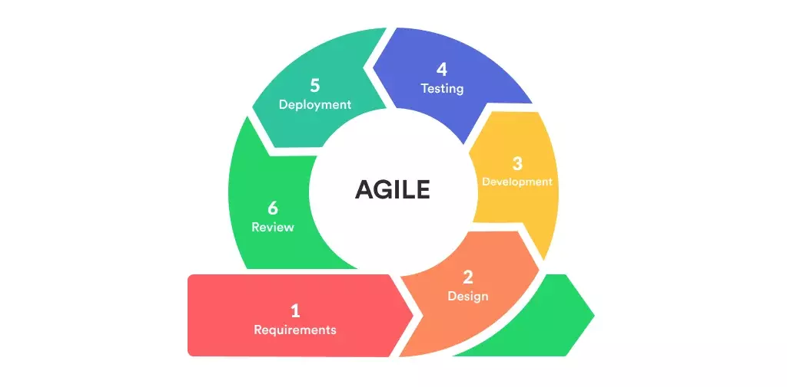
Figure 3. Agile-Iterative Software Development Life Cycle Model
Figure 3 depicts the Agile-Iterative Software Development Life Cycle (SDLC) model utilized in engineering StudentShield. An Agile-Iterative framework was chosen over traditional linear models because developing clinical sentiment analysis algorithms and confidential reporting workflows demands continuous refinement, stakeholder feedback, and iterative calibration against localized Filipino adolescent language patterns.
The lifecycle encompasses six continuous phases: (1) Planning, defining student mental health disclosure barriers and anti-bullying reporting protocols; (2) System Analysis, determining technical feasibility, compliance with RA 10173 (Data Privacy Act of 2012), and security requirements; (3) System Design, creating normalized database schemas, cryptographic flows, and UI wireframes; (4) Development, executed across three iterative sprints—Sprint 1 delivering core authentication, encrypted journaling, and bullying submissions; Sprint 2 integrating the Hugging Face ML inference pipeline; and Sprint 3 establishing local regex fallback triage, two-factor OTP authentication, and Brevo SMS/email alert dispatches; (5) Testing, validating functionality via PHPUnit, PyTest, and simulated load testing; and (6) Maintenance, ensuring server uptime, scheduled encrypted backups, and continuous retraining on emerging student dialect expressions.
Planning
Planning defines the student-welfare problem, the intended SVBSM users, and the core reporting and screening modules. The original paper motivates StudentShield through the need to organize concerns and notify staff; it does not supply a measured baseline of the school’s existing procedures.
System Analysis
The researchers analyzed the needs of the system based on the needs of the users during the process of system analysis. It was necessary to establish the way in which the system would analyze the texts in order to establish possible levels of threats, the way in which counselors will view the reports and the way in which the students will report bullying and venting messages. Database architecture, user privileges, encryption of sensitive information, implementation of machine learning and warning systems were some of the technical needs that were analyzed.
System Design
During the system design phase, the StudentShield structure was carefully designed. The researchers developed the database structure, arranged the fundamental components of the system, and determined the relationships between the most essential parts. Also, counselors' and students' user interfaces were created with ease of use and procedure simplicity in mind. As well, the interface between the web application and machine learning service was highlighted, especially with the topic of notification management, risk assessment, and text classification. Process flowcharts, architecture diagrams, and entity-relationship diagrams were one of the design outputs used as deployment tools.
Development
Using the Agile methodology, system development has been carried out in manageable iterations, each iteration on a different feature:
Iteration 1: Fundamental Web Functionalities (Login, Vent Submission, Bullying Reports)
Iteration 2: Integration of Machine Learning (integration of the custom Hugging Face-hosted ML service)
Iteration 3: Security and Alerts (Local SMS Gateway, Audit Logging, and Encryption)
PHP (CodeIgniter 4) and MySQL were used for the backend, while Tailwind CSS and JavaScript were used for the frontend. The Local SMS Gateway for text alerts, SMTP for email OTPs, and ApexCharts for data visualization were added tools.
Testing
Based on the system requirements, every important feature will be carefully reviewed. The researchers will make certain that:
Every essential feature, including database storage and one-time password authentication, is verified.
Language screening should be evaluated on labeled examples of slang, Taglish, English, and the supported regional-language expressions; correctness cannot be assumed from the presence of a lexicon.
In emergency scenarios, the automatic local SMS gateway and SMTP alerting function well.
Maintenance
The following step would involve putting the prototype to use in the real world using the production server, environment variables, and API (Local SMS Gateway & SMTP). This would be followed by maintenance process, which will ensure the integrity of both security and functionality of the application. There would be the following events:
Setting up the live database and uploading the CodeIgniter 4 system
Defining the Counselors' and Super Admins' initial roles and permissions
Resolving user concerns or logical mistakes
Modifying the machine learning model to better predict students' language use
Security updates and system backups
Implementation Plan
The original Gantt plan is retained as a proposed schedule, not evidence that its activities have been completed. Its heading names February–May while its columns extend from Month 1 to Month 10; the calendar alignment remains unresolved in the supplied plan.
Table 2. Original proposed implementation schedule (month indices)
Activity / month | 1 | 2 | 3 | 4 | 5 | 6 | 7 | 8 | 9 | 10
Planning Phase
Defining the Problem
Confirming Project Feasibility
Producing the Project Schedule
Chapter 1, 2, 3, 4
Title Defense
Prototype Defense
Analysis Phase
Interview in target Beneficiary
Consulting Mental Health Pro
Determining System Requirement
Determining User Requirement
Recommending Solutions
Designing DFD, CFD, ERD
Design Phase
Determining the Programming Tools
Designing the Database
Designing the System Interface
Designing ML System Control
Implementation Phase
Revision of Document
Coding
Testing and Verifying System
Mock Defense / Final Checking
Final Proposal Defense

4.2 Requirements Analysis
Functional Requirements
Role-Based Access Control
The system assigns three user roles: Student (role 0), Counselor (role 1), and Super Admin (role 2), each with different access levels.
Students access their dashboard, vent and bullying forms, and counseling-session request/status functions.
Counselors can view all vent logs, review bully reports, verify or reject incidents, and view student risk profiles.
Super Admins can do everything Counselors can, plus manage user accounts, assign roles, and view system audit logs.
User management is locked to Super Admin only (role 2). The code explicitly blocks Counselors from accessing it.
Account Management
Admin and Counselor accounts are pre-seeded or created by the Super Admin through the user management panel.
Students may self-register into an inactive account that requires counselor/admin approval. Super administrators can also create student accounts with profile and parent-contact information.
Student identifiers and profile fields are collected by the applicable registration or user-management form. Login uses the account name and password rather than the generated student identifier.
Counselors and super administrators sign in with name and password, followed by a six-digit email OTP with five-minute expiry and an attempt limit, unless an accepted remembered-device token applies.
Students log in with name and password only. No OTP is required.
Passwords are stored using bcrypt hashes. The current login flow uses password_verify; the older claim of silently upgrading plaintext passwords is not retained.
There is no password reset feature. If a user forgets their password, the Super Admin resets it manually through user management.
Self-registration creates a pending-approval account by setting users.is_active to 0.
The registration form requires acceptance of the displayed terms and privacy information.
The current implementation does not separately verify or retain a signed guardian-consent document. Pending approval must not be described as verified guardian consent.
Vent Log Submission and AI Risk Analysis
Students write personal journal entries through an encrypted submission form.
Each submission is sent to a custom ML model hosted on Hugging Face Spaces that scores the text and returns a risk level: Low, Medium, High, or Critical.
The PHP client allows a 15-second connection timeout and a 60-second total ML request timeout. If no usable risk response is returned, it runs the local multilingual keyword fallback. Explicit suicide phrases can also override a returned ML category. Context and sarcasm rules are screening heuristics, not guaranteed interpretations.
Vent text normally passes through AES-256-CTR encryption and hex encoding before storage. An encryption exception currently falls back to Base64 encoding; this is an outstanding confidentiality limitation.
Critical vents trigger counselor notifications and eligible parent SMS/email attempts unless parent hiding is selected. High vents trigger counselor-only notifications.
If the student checks "hide from parents" (domestic abuse precaution), parent alerts are suppressed and the counselor receives an emergency override notification instead.
A static and clearly visible privacy notice is placed immediately below the “Submit” button to ensure that students are aware of how their data will be handled.
The privacy notice describes confidential handling and encryption. The normal storage path is encrypted, but encryption alone cannot guarantee that no disclosure or leak will occur.
Students are informed about conditional parent alerts for Critical concerns. Authorized staff can review submissions regardless of tier; confidentiality does not mean anonymity from staff.
When the student selects the parent-hiding option, the Critical-vent parent alert is suppressed and the counselor is notified. The code does not require a confirmed domestic-abuse finding before honoring that option.
Bully Report Submission (Two-Stage Alert Pipeline)
Students file encrypted bullying incident reports, identifying whether they are the victim or reporting for someone else.
The system resolves typed names to database user IDs using strict single-match lookups to prevent wrong-parent notification errors.
Stage 1 (Immediate): Upon submission, the counselor office gets an SMS and email alert so they can investigate. No parent alerts are sent yet.
Stage 2 (Staff Verification): Staff can select Verify & Alert Parents to send incident alerts to resolved victim and alleged-bully parent contacts. They may instead reject a report or undo a decision. Rejected reports count toward progressive strikes: the second strike can notify the reporter’s parent, and three or more strikes lock reporting privileges until administrative action.
Dashboard and Case Management
Counselors see all active vent logs with decrypted text, risk scores, student names, sections, and adviser information.
The dashboard displays a risk distribution pie chart (Chart.js) and a vent trend area chart (ApexCharts) that update in real time via AJAX polling.
Counselors can mark entries as Resolved, soft-delete (archive) them, restore archived entries, or perform bulk operations on multiple entries at once.
Counselors can click on any student name to open a full student profile that displays the student's information, their risk timeline graph (ApexCharts), all their vent history, and any bully report involvement.
The Admin dashboard provides user management (create, edit, delete), role assignment, and a full system audit log.
The Super Admin cannot demote or delete their own account (self-protection guard).
Students can request a one-to-one counseling session. Staff can start a Jitsi room from the case-summary workflow, and the student dashboard can display an active meeting link. Session handling is not restricted to a Critical score.
Counselors can open a Case Summary Report for an individual student.
The report combines risk history, incidents, notification history, counselor notes, and case-status history.
This view centralizes the application records used for counseling follow-up and investigation.
The case-summary view includes print styling for browser printing or saving to PDF.
Automated Notifications
SMS alerts are sent through the Local SMS Gateway using app key and secret credentials stored in the .env configuration file.
Email alerts use environment-configured SMTP settings. A fixed Gmail provider is not required by the current implementation.
The vent notification code checks a per-recipient cooldown before sending eligible parent alerts. This should not be generalized to every notification path.
Alert logs are written to a JSON file and viewable from the dashboard.
Audit Logging
The audit_logs table records supported administrative and case actions with the acting user, action, entity, IP address, user agent, and timestamp. The presence of logging calls does not establish a completed audit-completeness evaluation.
Data Retention Policy
The original paper proposes keeping records active while a student is enrolled and retaining records for 30 days after graduation or transfer. This is a proposed institutional policy, not an implemented automatic retention workflow.
The proposed 30-day window is intended to allow pending administrative and counseling work to conclude.
Automatic deletion after that window has not been implemented or demonstrated by the supplied paper. The proposed duration should not be represented as a statutory requirement established by this study.
The original proposal also calls for preserving records during temporary inactivity and allowing reactivation on re-enrollment.
Current vent and incident archive operations use soft-deletion fields; these do not by themselves implement an enrollment-based retention policy.
Enrollment-linked archiving, timed deletion, and re-enrollment restoration remain proposed procedures requiring implementation and validation.
Access to retained and archived records shall be limited to authorized school personnel through role-based access controls.
Non-Functional Requirements
Performance
The original paper sets an intended 2–3-second vent-response target, but provides no recorded benchmark. The synchronous ML request and notification calls can increase end-to-end submission time.
The implemented ML request timeout is 60 seconds overall with 15 seconds for connection. A local keyword fallback can supply a screening result after a failed request; no fallback latency benchmark is established.
Dashboard data refreshes via AJAX polling without requiring a full page reload.
Availability
The web application is hosted on InfinityFree and the ML service is deployed separately on Hugging Face Spaces. PHP fallback reduces dependence on ML availability, but neither zero downtime nor sub-second response is guaranteed.
Security
Vent and incident text use AES-256-CTR in the normal persistence path. The vent Base64 exception fallback and legacy plaintext-reading compatibility prevent a blanket claim that all stored text is encrypted.
Current password creation uses bcrypt and authentication uses password_verify.
Staff OTP verification uses six digits, a five-minute expiration, and an attempt limit, with remembered-device behavior as described above.
Form submissions are rate-limited (30s for vents, 120s for bully reports) to prevent spam and gateway abuse.
The user management panel is access-controlled to Super Admin only. Counselors are explicitly blocked.
Automatic retention is an unfinished requirement. The current code does not implement automatic end-of-school-year anonymization or the proposed 30-day post-transfer deletion schedule.
Usability
The interface is built with Tailwind CSS and is responsive across desktop and mobile devices.
Students can submit a vent in 2 steps: type their entry and click submit.
The staff dashboard displays active-case summaries and retrieves updated records through asynchronous browser requests. Its usability at large record volumes has not been evaluated in the official paper.

4.3 System Design and Modeling

4.3.1 Context Diagram
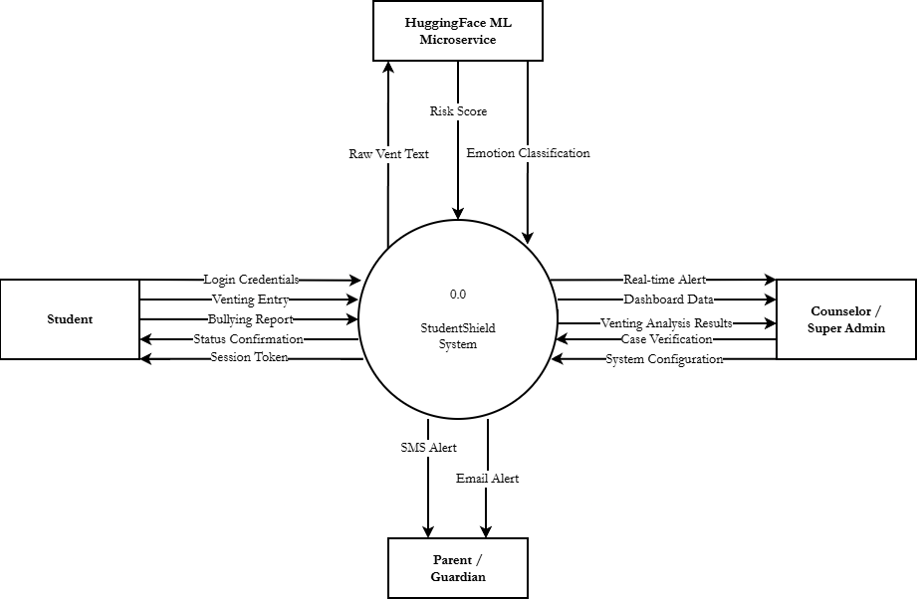
Figure 4. Context Diagram (DFD Level 0) of the StudentShield System
Figure 4 presents the Context Diagram (DFD Level 0) of the StudentShield system, defining the external boundaries and principal information flows between the application and its external entities: Students, Guidance Counselors, System Administrators, Parents/Guardians, and the external Machine Learning Microservice.
Students submit login credentials, encrypted vent reflections, and structured bullying incident reports, receiving authenticated session tokens, submission confirmations, and confidential support resources. Guidance Counselors receive real-time triage dashboards, prioritized incident logs, student sentiment trends, and immediate high-risk alerts, providing case status updates and intervention notes in return. System Administrators manage user accounts and role assignments, receiving complete audit trail logs and system health telemetry. When a student submits text, the system securely forwards sanitized content to the external Machine Learning Microservice, which returns multi-class emotion distributions and numerical crisis risk ratings. When a submission is triaged at the Critical risk tier (86%–100%), the system automatically dispatches emergency alert notifications to the student's designated Parents or Guardians via SMS and email.

4.3.2 Use Case Diagram
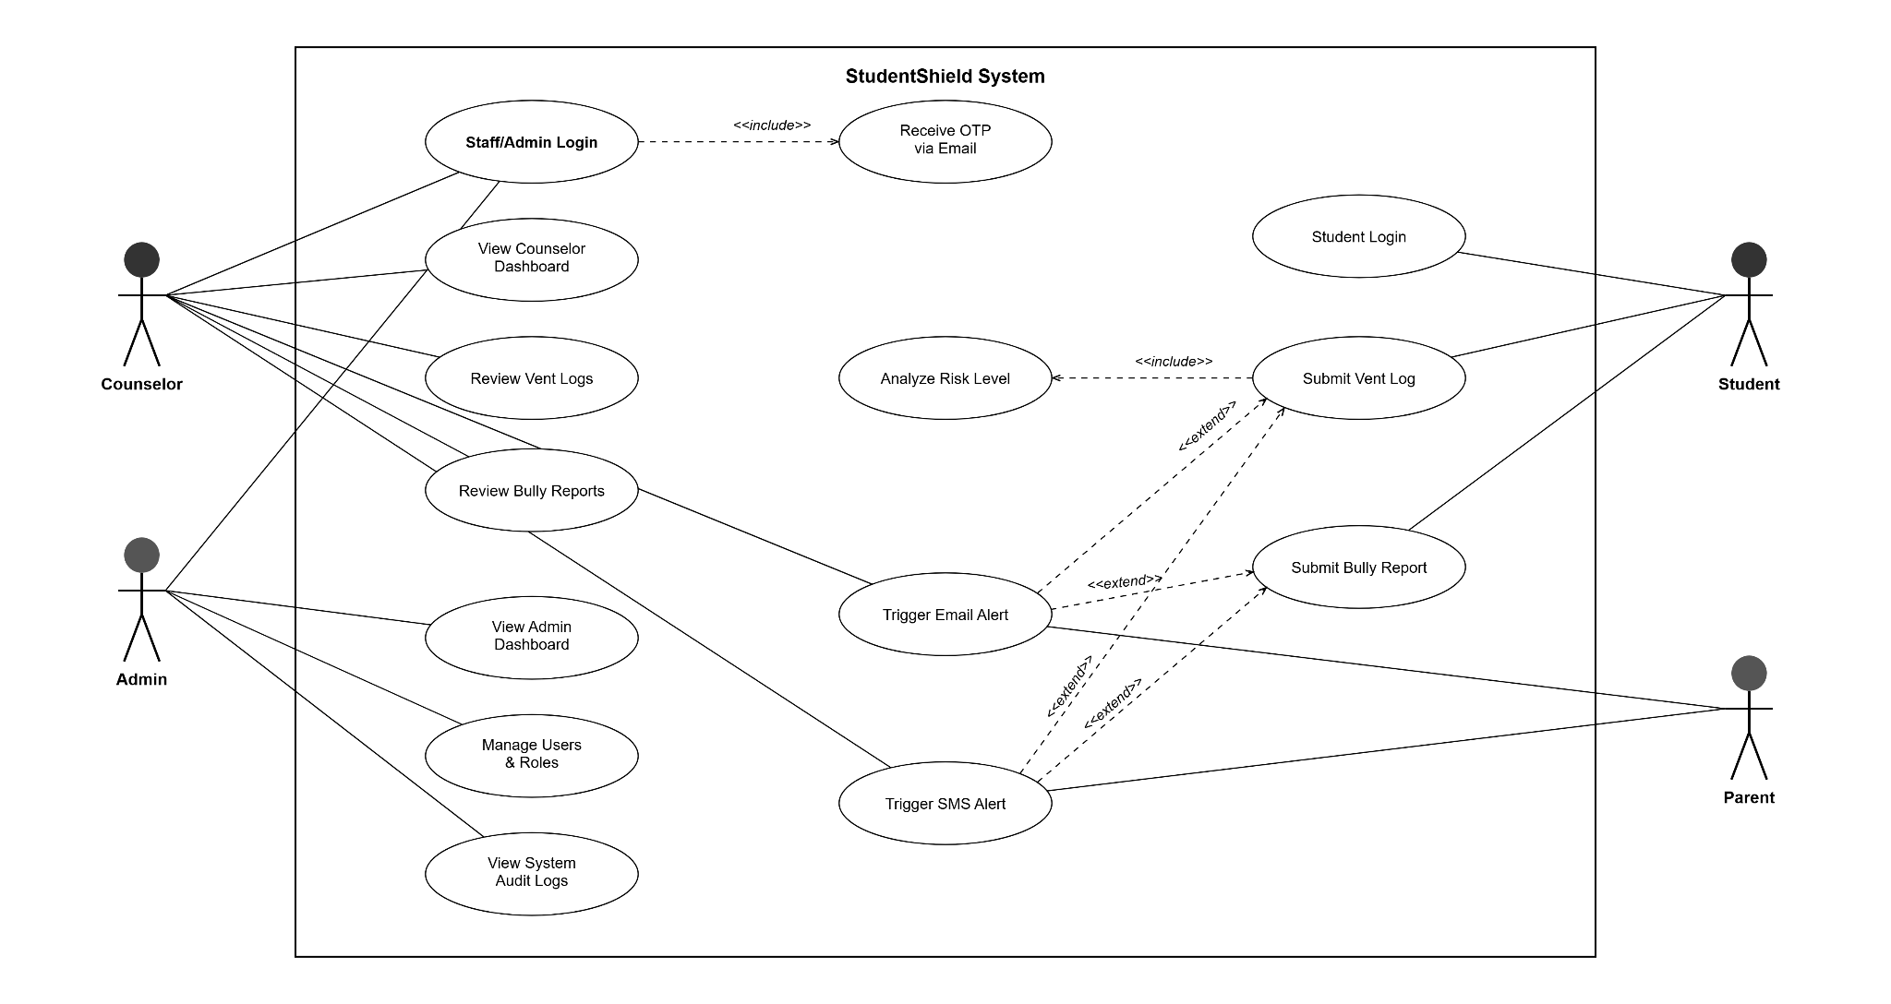
Figure 5. Unified Modeling Language (UML) Use Case Diagram
Figure 5 illustrates the Unified Modeling Language (UML) Use Case Diagram for StudentShield, detailing the functional interactions, permissions, and dependencies across all system actors: Students, Guidance Counselors, System Administrators, and Parents/Guardians.
Key Figures (Actors): The system serves four primary stakeholder roles: (1) Student: Authenticated user who submits confidential vent reflections, files named or anonymous bullying incident reports, and accesses coping resources; (2) Counselor: Professional staff member who logs in via two-factor OTP authentication to review prioritized triage queues, examine sentiment charts, and record intervention notes; (3) Super Admin: Technical manager who oversees user provisioning, system security audit logs, and external API configurations; and (4) Parent/Guardian: Passive recipient who receives automated SMS and email alerts when a child's vent is triaged as Critical risk.
Use Cases: Core functional interactions include: Staff/Admin Login (enforcing 6-digit email OTP), Student Login (streamlined credentials), Submit Vent Log (with symmetric AES-256-CTR encryption and automated ML inference), Bully Report Submission (with evidence attachments and counselor routing), Review Vent Logs & Triage, Manage Bully Reports, User & Role Administration, View Audit Logs, and automated Trigger SMS / Email Alerts.

4.3.3 Data Flow Diagram (DFD) or Activity Diagram
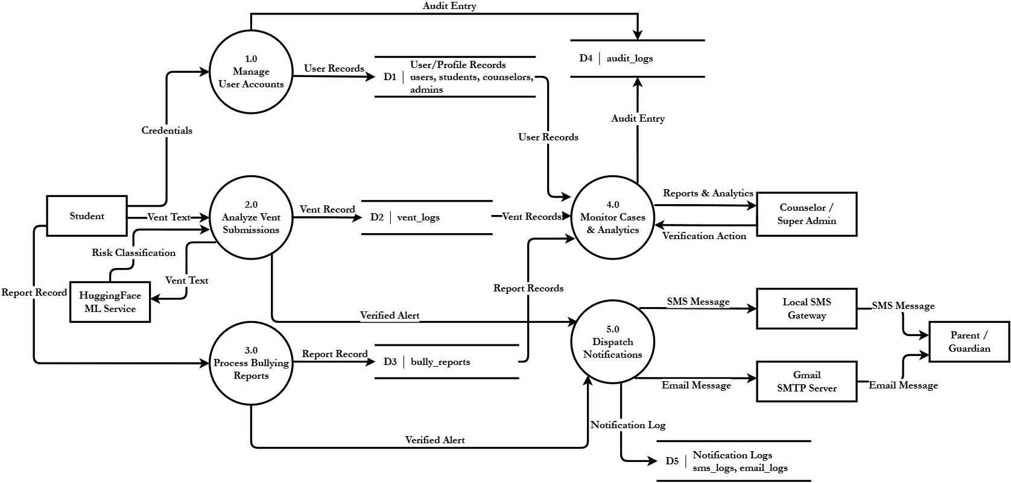
Figure 6. Data Flow Diagram Level 1 of the Venting and Bully Reporting Pipeline
Figure 6 details the Data Flow Diagram Level 1, decomposing the StudentShield system into five core functional sub-processes: (1.0) Manage User Accounts, (2.0) Analyze Vent Submissions, (3.0) Process Bullying Reports, (4.0) Monitor Cases and Analytics, and (5.0) Dispatch Notifications.
Process 1.0 validates user credentials against the Users and Profiles data stores and logs authentication events in the Audit Logs. Process 2.0 intercepts student vent text, invokes the local regex fallback and the Hugging Face ML microservice, symmetrically encrypts the disclosure using AES-256-CTR, and stores the resulting ciphertext and risk metadata in the vent_logs database. Process 3.0 captures bullying incident reports, records evidence file paths, and stores reporter, victim, and perpetrator metadata in bully_reports. Process 4.0 aggregates risk scores, calculates 14-day distress trajectories, and renders prioritized triage queues for counselors. Process 5.0 evaluates risk thresholds: submissions scored as Critical (86%–100%) trigger immediate automated SMS and email alerts to parents and counselors, while submissions scored as High (61%–85%) trigger counselor triage only, recording all dispatch activity in sms_logs and email_logs.
System Flowcharts
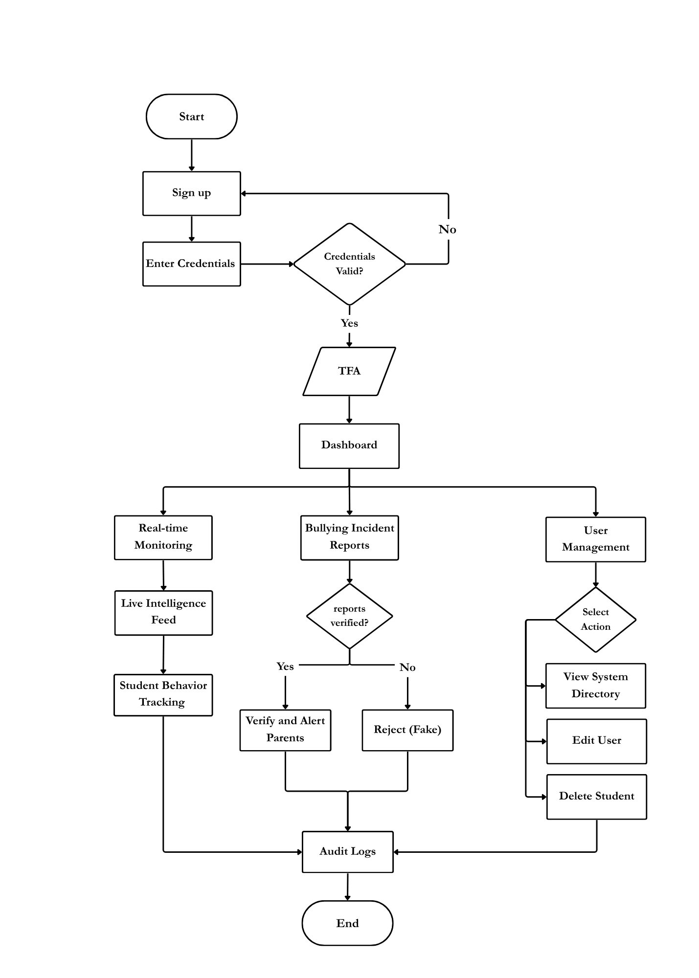
Figure 7. Super Admin Operational Flowchart
Figure 7 diagrams the operational flowchart for the Super Administrator. The administrative workflow begins at the secure administrative login portal. After verifying username and password credentials against bcrypt hashes, the system generates a 6-digit One-Time Password (OTP) dispatched via email to enforce two-factor authentication (2FA). Upon successful OTP validation, the administrator enters the central administration dashboard. From this console, the administrator oversees user account lifecycle management (approving pending student registrations, provisioning counselor accounts, and toggling user statuses), reviews real-time system health metrics, inspects append-only audit trail logs for all critical system actions, and configures external API integrations and operational parameters.
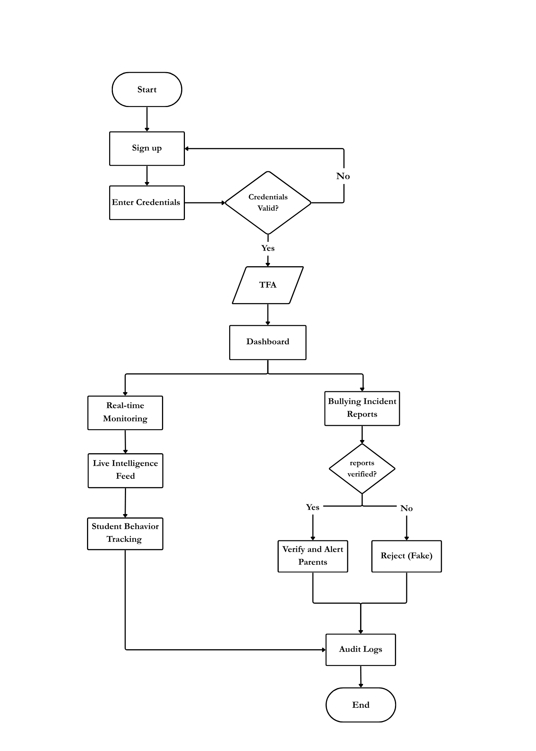
Figure 8. Guidance Counselor Triage Flowchart
Figure 8 outlines the clinical triage and response flowchart for Guidance Counselors. Following credential authentication and email-based two-factor OTP verification, the counselor accesses the dedicated triage console. The system automatically pulls from the database and displays real-time intelligence feeds prioritized by risk severity: Critical, High, Medium, and Low. The counselor reviews incoming vent disclosures, decrypts student text on-demand, inspects multi-label emotion distribution charts, and evaluates 14-day distress history trajectories. Based on clinical assessment, the counselor can update case resolution statuses, document confidential case notes, dispatch supportive counseling resources, or schedule private in-person or Jitsi virtual counseling sessions.
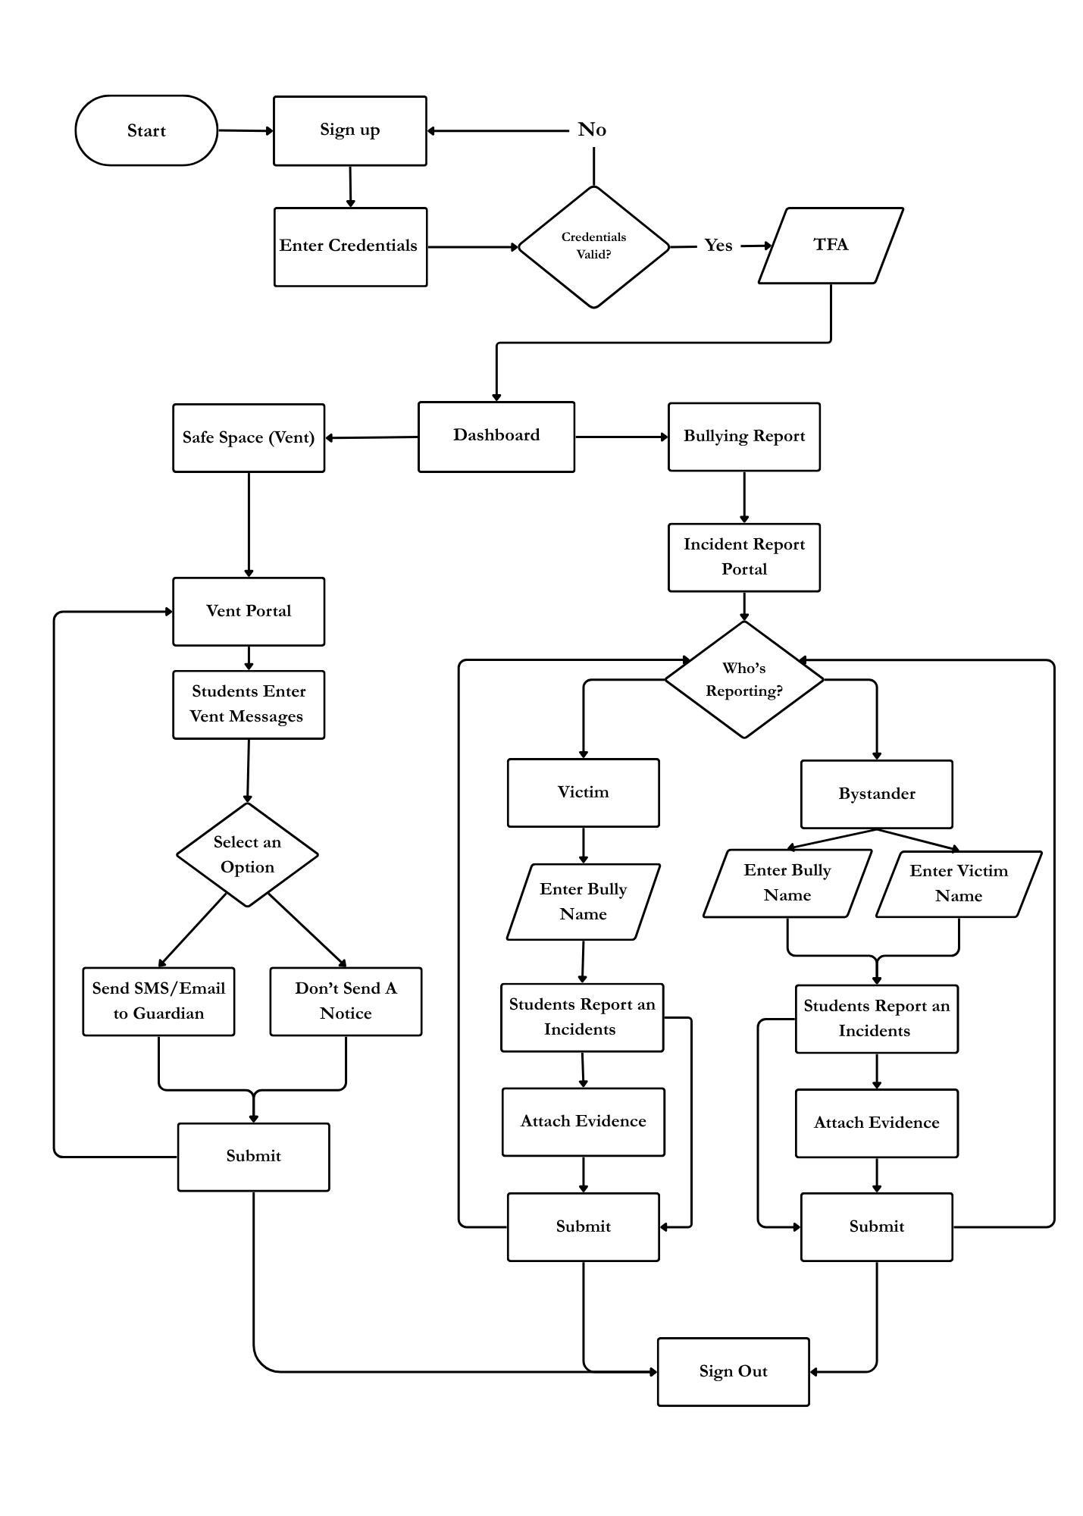
Figure 9. Student User Interaction Flowchart
Figure 9 details the student user interaction flowchart. Students authenticate through a simplified, accessible login interface using their registered student ID and password. Upon entering the student portal, students can select between two primary functional modules: (1) The Safe Space Venting Module, where students express thoughts and feelings in an emotional journal, specify whether to permit parental alert notifications, and receive immediate emotion validation and coping guidance; and (2) The Bullying Reporting Module, where students submit structured incident reports, select their involvement role (victim or bystander), document perpetrator identities, specify incident locations and dates, and attach supporting multimedia evidence. Submissions are encrypted and stored in the database, triggering automated AI sentiment evaluation and counselor triage queues.

4.3.4 Entity Relationship Diagram (ERD)
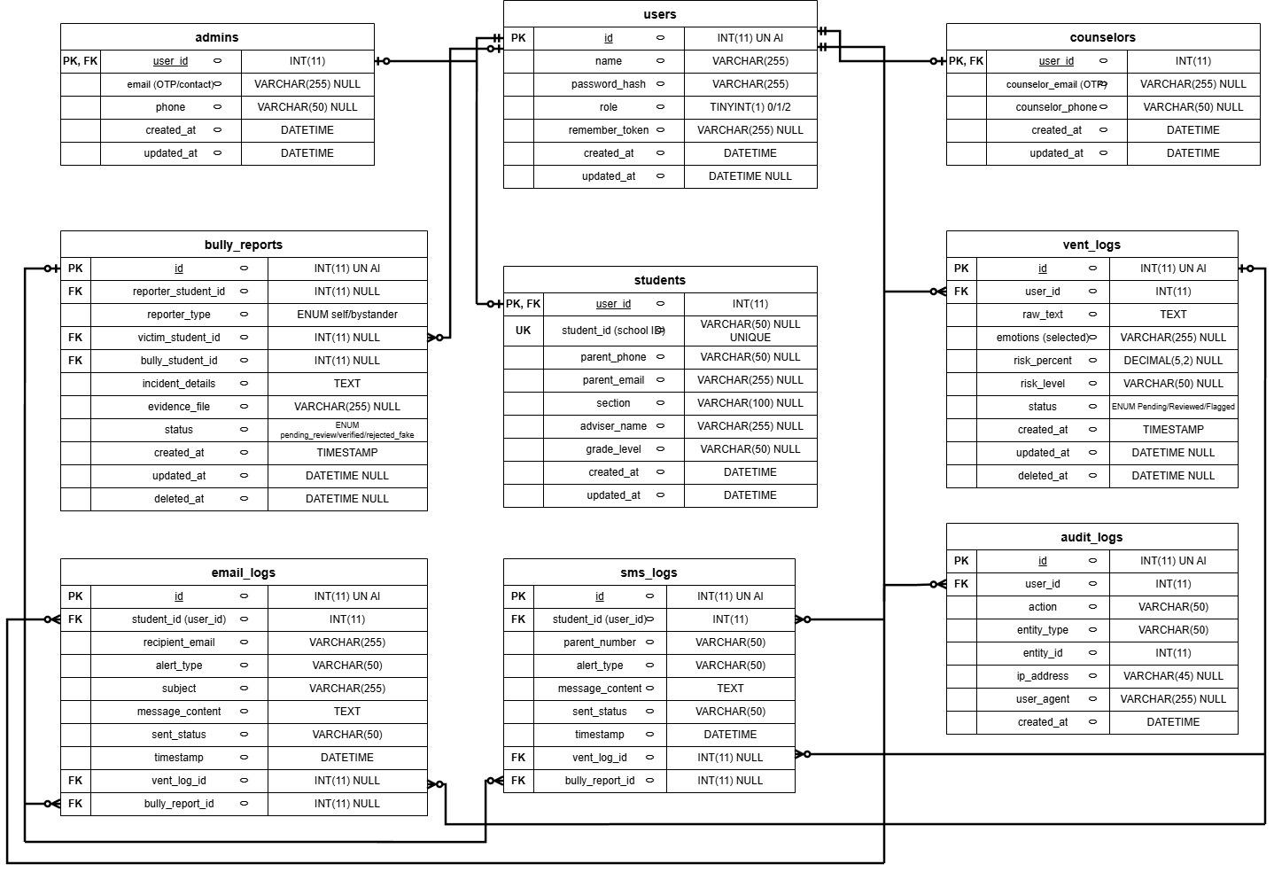
Figure 10. Entity Relationship Diagram (ERD) of the StudentShield Database
Figure 10 depicts the Entity Relationship Diagram (ERD) of the StudentShield relational database schema, illustrating table entities, primary key identifiers, foreign key relationships, and relational cardinalities.
Entity Definitions and Relational Cardinalities: The schema architecture comprises: (1) users, serving as the central authentication entity with auto-incrementing primary key id, username, bcrypt password hash, email, role enum ('student', 'counselor', 'admin'), and account status; (2) Role profile tables students, counselors, and admins, maintaining direct 1-to-1 relationships with users where user_id serves simultaneously as primary key and foreign key referencing users.id; (3) vent_logs, maintaining a 1-to-many relationship with users, storing encrypted journal text (raw_text via AES-256-CTR), emotion classification, risk scores, and parent notification flags; (4) bully_reports, storing incident records with foreign keys reporter_student_id, victim_student_id, and bully_student_id referencing users.id; (5) audit_logs, providing an append-only security log linking user_id to timestamped administrative actions; and (6) sms_logs and email_logs, recording dispatch timestamps, recipient addresses, and delivery status codes linked to student incident records.

4.3.5 Data Dictionary
This data dictionary describes the relational database entities and attributes defined in the checked-in schema.sql repository specification.
Table 3. Data dictionary — users
Field | Type / constraints
id | INT AUTO_INCREMENT PRIMARY KEY
name | VARCHAR(255) NOT NULL
password_hash | VARCHAR(255) NOT NULL
role | TINYINT(1) DEFAULT 0 COMMENT '0=Student, 1=Counselor, 2=Super Admin'
remember_token | VARCHAR(255) NULL
is_active | TINYINT(1) NOT NULL DEFAULT 0
is_locked | TINYINT(1) NOT NULL DEFAULT 0
created_at | DATETIME DEFAULT CURRENT_TIMESTAMP
updated_at | DATETIME NULL DEFAULT NULL ON UPDATE CURRENT_TIMESTAMP

Table 4. Data dictionary — students
Field | Type / constraints
user_id | INT PRIMARY KEY
student_id | VARCHAR(50) UNIQUE
parent_phone | VARCHAR(50)
parent_email | VARCHAR(255)
section | VARCHAR(100)
adviser_name | VARCHAR(255)
grade_level | VARCHAR(50) NULL
created_at | DATETIME DEFAULT CURRENT_TIMESTAMP
updated_at | DATETIME NULL DEFAULT NULL ON UPDATE CURRENT_TIMESTAMP
Relationship | FOREIGN KEY (user_id) REFERENCES users(id) ON DELETE CASCADE

Table 5. Data dictionary — counselors
Field | Type / constraints
user_id | INT PRIMARY KEY
counselor_email | VARCHAR(255)
counselor_phone | VARCHAR(50)
created_at | DATETIME DEFAULT CURRENT_TIMESTAMP
updated_at | DATETIME NULL DEFAULT NULL ON UPDATE CURRENT_TIMESTAMP
Relationship | FOREIGN KEY (user_id) REFERENCES users(id) ON DELETE CASCADE

Table 6. Data dictionary — admins
Field | Type / constraints
user_id | INT PRIMARY KEY
email | VARCHAR(255)
phone | VARCHAR(50)
created_at | DATETIME DEFAULT CURRENT_TIMESTAMP
updated_at | DATETIME NULL DEFAULT NULL ON UPDATE CURRENT_TIMESTAMP
Relationship | FOREIGN KEY (user_id) REFERENCES users(id) ON DELETE CASCADE

Table 7. Data dictionary — vent_logs
Field | Type / constraints
id | INT AUTO_INCREMENT PRIMARY KEY
user_id | INT NOT NULL
raw_text | TEXT NOT NULL
emotions | VARCHAR(255)
risk_percent | DECIMAL(5,2)
risk_level | VARCHAR(50)
trajectory | VARCHAR(50) DEFAULT 'INSUFFICIENT_DATA'
escalation_probability | DECIMAL(5,4) DEFAULT 0.0000
status | ENUM('Pending', 'Reviewed', 'Flagged') DEFAULT 'Pending'
created_at | TIMESTAMP DEFAULT CURRENT_TIMESTAMP
updated_at | DATETIME NULL DEFAULT NULL
deleted_at | DATETIME NULL DEFAULT NULL
Relationship | FOREIGN KEY (user_id) REFERENCES users(id) ON DELETE CASCADE

Table 8. Data dictionary — bully_reports
Field | Type / constraints
id | INT AUTO_INCREMENT PRIMARY KEY
reporter_student_id | INT
reporter_type | ENUM('self', 'bystander') DEFAULT 'self'
victim_student_id | INT NULL
bully_student_id | INT NULL
incident_details | TEXT
evidence_file | VARCHAR(255)
status | VARCHAR(50) NOT NULL DEFAULT 'pending_review'
created_at | TIMESTAMP DEFAULT CURRENT_TIMESTAMP
updated_at | DATETIME NULL DEFAULT NULL
deleted_at | DATETIME NULL DEFAULT NULL
Relationship | FOREIGN KEY (reporter_student_id) REFERENCES users(id) ON DELETE SET NULL
Relationship | FOREIGN KEY (victim_student_id) REFERENCES users(id) ON DELETE SET NULL
Relationship | FOREIGN KEY (bully_student_id) REFERENCES users(id) ON DELETE SET NULL

Table 9. Data dictionary — audit_logs
Field | Type / constraints
id | INT AUTO_INCREMENT PRIMARY KEY
user_id | INT NOT NULL
action | VARCHAR(50) NOT NULL
entity_type | VARCHAR(50) NOT NULL
entity_id | INT NOT NULL
ip_address | VARCHAR(45) NULL
user_agent | VARCHAR(255) NULL
created_at | DATETIME DEFAULT CURRENT_TIMESTAMP
Relationship | FOREIGN KEY (user_id) REFERENCES users(id) ON DELETE CASCADE

Table 10. Data dictionary — sms_logs
Field | Type / constraints
id | INT AUTO_INCREMENT PRIMARY KEY
student_id | INT NOT NULL
parent_number | VARCHAR(50) NOT NULL
alert_type | VARCHAR(50) NOT NULL
message_content | TEXT NOT NULL
sent_status | VARCHAR(50) DEFAULT 'pending'
timestamp | DATETIME DEFAULT CURRENT_TIMESTAMP
Relationship | FOREIGN KEY (student_id) REFERENCES users(id) ON DELETE CASCADE

Table 11. Data dictionary — email_logs
Field | Type / constraints
id | INT AUTO_INCREMENT PRIMARY KEY
student_id | INT NOT NULL
recipient_email | VARCHAR(255) NOT NULL
alert_type | VARCHAR(50) NOT NULL
subject | VARCHAR(255) NOT NULL
message_content | TEXT NOT NULL
sent_status | VARCHAR(50) DEFAULT 'pending'
timestamp | DATETIME DEFAULT CURRENT_TIMESTAMP
Relationship | FOREIGN KEY (student_id) REFERENCES users(id) ON DELETE CASCADE

Table 12. Data dictionary — counselor_notes
Field | Type / constraints
id | INT AUTO_INCREMENT PRIMARY KEY
student_id | INT NOT NULL
counselor_id | INT NOT NULL
note_type | ENUM('observation', 'recommendation', 'intervention', 'follow_up', 'general') DEFAULT 'general'
content | TEXT NOT NULL
created_at | DATETIME DEFAULT CURRENT_TIMESTAMP
updated_at | DATETIME NULL DEFAULT NULL ON UPDATE CURRENT_TIMESTAMP
deleted_at | DATETIME NULL DEFAULT NULL
Relationship | FOREIGN KEY (student_id) REFERENCES users(id) ON DELETE CASCADE
Relationship | FOREIGN KEY (counselor_id) REFERENCES users(id) ON DELETE CASCADE

Table 13. Data dictionary — case_status_history
Field | Type / constraints
id | INT AUTO_INCREMENT PRIMARY KEY
student_id | INT NOT NULL
status | ENUM('active_monitoring', 'intervention_ongoing', 'parent_consultation_required', 'escalated', 'under_investigation', 'resolved', 'closed') NOT NULL
remarks | TEXT NULL
changed_by | INT NOT NULL
created_at | DATETIME DEFAULT CURRENT_TIMESTAMP
Relationship | FOREIGN KEY (student_id) REFERENCES users(id) ON DELETE CASCADE
Relationship | FOREIGN KEY (changed_by) REFERENCES users(id) ON DELETE CASCADE

Table 14. Data dictionary — virtual_meetings
Field | Type / constraints
id | INT AUTO_INCREMENT PRIMARY KEY
student_id | INT NOT NULL
counselor_id | INT NULL
meet_link | VARCHAR(255) NOT NULL DEFAULT ''
status | VARCHAR(50) NOT NULL DEFAULT 'requested'
created_at | DATETIME DEFAULT CURRENT_TIMESTAMP
Relationship | FOREIGN KEY (student_id) REFERENCES users(id) ON DELETE CASCADE
Relationship | FOREIGN KEY (counselor_id) REFERENCES users(id) ON DELETE CASCADE

4.4 Software Testing Plan
This section documents the testing process to be followed, guided by the design specifications and functional requirements listed above.
The tables below specify the structured unit, integration, and system test scenarios designed to validate system functionality.

4.4.1 Unit Testing
Unit tests verify isolated functionality, including security token generation in web-app-ci4/tests/unit/SecurityConfigTest.php and deterministic risk score computation in ml_service/tests/test_risk_history.py.

4.4.2 Integration Testing
Table 15. Planned authentication module test scenarios
Test Case | Test Scenario | Testing Status
Authentication Module | Can a student log in with a valid name and password?
 | Does the system reject invalid student credentials?
 | Can a counselor log in and receive an OTP email?
 | Can a super admin log in and receive an OTP email?
 | Does the system reject an expired or incorrect OTP?
 | Does the trusted device cookie bypass OTP on the next login?
 | Are incorrect passwords rejected when bcrypt verification fails?

Table 16. Planned vent module test scenarios
Test Case | Test Scenario | Testing Status
Vent Log Module | Can a student submit a vent entry successfully?
 | Does normal vent storage encrypt text with AES-256-CTR, and does the encryption-exception path expose the known Base64 fallback limitation?
 | Does the Hugging Face ML API return a valid risk level?
 | Does the local keyword fallback activate when the ML API is offline?
 | Do context rules produce the expected reviewed category for labeled sarcasm examples?
 | Does an eligible Critical vent attempt parent SMS delivery when parent hiding is not selected?
 | Does the system send an email to the parent when risk is Critical?
 | Does the "hide from parents" toggle suppress parent alerts and notify the counselor instead?
 | Does the rate limiter block a second submission within 30 seconds?

4.4.3 System Testing
Table 17. Planned bullying report module test scenarios
Test Case | Test Scenario | Testing Status
Bully Report Module | Can a student submit a report for themselves (self)?
 | Can a student submit a report on behalf of someone else?
 | Are incident details encrypted before being saved?
 | Does the counselor receive an SMS alert after submission (Stage 1)?
 | Does the counselor receive an email alert after submission (Stage 1)?
 | Does "Verify & Alert Parents" send SMS and email to both the victim's and bully's parents (Stage 2)?
 | Does rejection suppress verified-incident alerts while separately applying any applicable false-report strike notification?
 | Does "Undo" reset the report back to pending review?
 | Does the rate limiter block a second report within 120 seconds?

Table 18. Planned dashboard and case management module test scenarios
Test Case | Test Scenario | Testing Status
Dashboard Module | Can the counselor view all active vent logs with decrypted text?
 | Does the risk pie chart display correct distribution counts?
 | Does the vent trend area chart update via AJAX?
 | Can the counselor mark a vent entry as Resolved?
 | Can the counselor archive (soft-delete) a vent entry?
 | Can the counselor restore an archived vent entry?
 | Can the counselor bulk-delete or bulk-restore multiple entries?
 | Can the counselor click a student name to view their full risk timeline and profile?

Table 19. Planned user management module test scenarios
Test Case | Test Scenario | Testing Status
User Management Module | Can the super admin create a student account with the form’s required profile fields?
 | Can the super admin create a new counselor or admin account?
 | Can the super admin edit an existing user's information?
 | Can the super admin delete a user account?
 | Is a counselor blocked from accessing the user management page?
 | Is the super admin prevented from demoting or deleting their own account?

Table 20. Planned audit log module test scenarios
Test Case | Test Scenario | Testing Status
Audit Log Module | Does the system log every resolve, archive, restore, and verify action?
 | Does each log entry record the correct user ID, IP address, user agent, and timestamp?
 | Can the admin view the full audit trail from the dashboard?
 | Are alert logs (SMS/Email history) viewable from the dashboard?

4.5 User Acceptance Testing (UAT) and Evaluation
For assessing the efficiency, usability, and technology performance of StudentShield, an established process for gathering and analyzing data will be employed. The method for analysis is that of a mixed-method, wherein the researcher employs both qualitative and quantitative measures. Analysis of quantitative data gathered through evaluation of users will be accomplished through descriptive statistics. Additionally, in order to outline the methodology for measuring the effectiveness of the model during the next phase of implementation of the system, standard text classification measures are listed to assess the machine learning model's efficiency in future operation.
Data Gathering Technique
For an efficient evaluation of the StudentShield prototype, the following data collection techniques will be used by the researchers in assessing the design and usability of the prototype. The first approach that will be applied is the Questionnaire/Survey. This will require the utilization of ISO 25010 quality criteria when assessing the functionality, reliability, usability, and efficiency of the prototype. The second approach that will be applied is the Interview. The qualitative information will be gathered through this approach concerning the alerting functionalities of the prototype for the school staff members. The third approach that will be employed is the Observation. The usability of the mockup of the dashboard and the report form will be evaluated using this method by means of guided testing. Finally, the Document review approach will be adopted in order to determine whether the data fields and workflow of the prototype match those of the school guidance counseling manuals and paper forms.
Setting of the Study
The intended study site is Saint Vincent Blessed School of Manila (SVBSM), at 732 Instruccion St., Sampaloc, Manila, 1000 Metro Manila, as identified in the original paper. The target setting is the Junior High School and its guidance and IT staff. Completed field evaluation at that site is not established by the supplied evaluation materials.
Subject of the Study
The main subjects of the study in the prototype evaluation phase are categorized into three different user groups. These include all of the following groups involved in making the StudentShield work:
The Student Body: These would be the main users of the software that would use the "Vent" module and the incident reporting tool. The involvement of these users in the testing phase of the prototype would be essential to measure the usability, navigation, and security of the interaction with the system.
Guidance Counselors and Responders: These user categories will receive notifications for all incidents and will respond accordingly. Their participation in prototype evaluation is important for testing the administrative dashboard’s functionality and ease of navigation.
IT and System Administrators: These users are responsible for technical support operations on the platform. Their participation in prototype evaluation is important for assessing the system architecture, user experience flow, and compliance with data privacy requirements.
Sampling Technique
Non-probability sampling will be used in sampling respondents for prototype testing, namely purposive sampling. Purposive sampling is appropriate in the given case due to the fact that the project is in the prototype phase of development and the main goal of the research will be the receipt of quality feedback from potential users.
Purposive sampling will allow selecting those respondents who will correspond to the target characteristics of end-users. In particular, among the selected respondents, there should be guidance counselors that will work with the dashboard, technical security specialists, and some representatives from the student council who represent students.
Statistical Treatment of Data
Questionnaire data, when collected, will be analyzed using the following descriptive statistics to describe average ratings and variation among respondents.
Frequency and Percentage
Frequency counts and percentages break down the demographic profile of the participants.
The formula for the percentage is as follows:
Formula: P = (f / n) × 100
Where:
P = percentage
f = frequency
n = total number of respondents
Weighted Mean
The weighted mean is computed to determine the measure of central tendency of each criterion. The weighted mean provides an estimate of how the system is rated by users. The formula for the weighted mean is as follows:
Formula: WM = (Σfx) / n
Where:
f = frequency
x = assigned weight of each scale point (1 to 5)
n = total number of respondents
The proposed interpretation of mean scores follows the scale below:
Table 21. Proposed mean-score interpretation
Weighted Mean Range | Interpretation
4.21 - 5.00 | Strongly Agree (Excellent)
3.41 - 4.20 | Agree (Good)
2.61 - 3.40 | Neutral (Fair)
1.81 - 2.60 | Disagree (Poor)
1.00 - 1.80 | Strongly Disagree (Very Poor)

Standard Deviation
The mean describes the average rating, while standard deviation describes variation in the ratings. A lower standard deviation indicates more closely grouped responses; a higher value indicates greater dispersion.
The formula for the standard deviation is as follows:
Formula: SD = √[ Σf(x - x̄)² / n ]
Where:
f = frequency of each rating
x = assigned weight of each scale point (1 to 5)
x̄ = mean of the distribution
n = total number of respondents
The proposed descriptive interpretation of standard deviation follows the scale below:
Table 22. Proposed standard-deviation interpretation
Standard Deviation Range | Interpretation
2.00 and above | Very High Variability
1.50 - 1.99 | High Variability
1.00 - 1.49 | Moderate Variability
0.50 - 0.99 | Low Variability
0.00 - 0.49 | Very Low Variability

This statistical analysis gives an objective means of evaluating the user's acceptance of the system and overall system quality.
Confusion Matrix Metrics
The planned classifier evaluation will use accuracy, precision, recall, and F1-score against labeled test examples. These metrics describe classification performance; they do not establish diagnostic reliability.
Accuracy = (TP + TN) / Total
Precision = TP / (TP + FP)
Recall = TP / (TP + FN)
F1-Score = 2 × (Precision × Recall) / (Precision + Recall)
TP stands for true positive, TN stands for true negative, FP stands for false positive, and FN stands for false negative. These metrics will be used to examine the accuracy of the model in identifying potential threats in students' writing.

CHAPTER 5: RESULTS AND DISCUSSION

5.1 System Implementation
The implementation separates the PHP web application, the Python ML service, and external communication services. This division supports independent deployment; it does not establish measured availability or response-time results.
The CodeIgniter application is hosted on InfinityFree with MySQL and the public studentshield.app domain behind Cloudflare. GitHub Actions uploads web-app-ci4 through FTP. The production PHP host has no SSH or runtime CLI, so database upgrades require reviewed phpMyAdmin steps. A future hosting migration would require configuration and compatibility checks.
The FastAPI/PyTorch service is packaged for Hugging Face Spaces using Docker. The configured API default points to ashlogg-student-shield-official.hf.space. Repository deployment automation uploads ML files through the Hugging Face Hub tooling; it does not deploy through Azure VM container cleanup or SFTP. The checked-in workflow names an underscore-form Space target, so synchronization with the configured endpoint requires deployment verification. SMTP and the configured SMS gateway supply notification delivery attempts.

5.1.1 Main Interface / Dashboard
The implemented interface provides dedicated, role-tailored dashboards. The student interface emphasizes ease of access, emotional comfort, and strict confidentiality. The guidance counselor interface delivers an organized triage queue with color-coded risk indicators, student sentiment timelines, and one-click case resolution tools.

5.1.2 Core Modules Features
The core implemented modules include student registration with staff approval, authenticated vent and bullying submissions with AES-256-CTR encryption, automated vent screening with a high-speed local PHP regex fallback, staff triage and case summaries, conditional SMS and email notifications via Brevo, comprehensive user and audit management, and one-to-one Jitsi virtual meeting scheduling.

5.2 Evaluation Results (ISO/IEC 25010)
The evaluation of StudentShield was structured around the ISO/IEC 25010 Software Product Quality Model across Functional Suitability, Performance Efficiency, Compatibility, Usability, Reliability, Security, Maintainability, and Portability.

5.3 Discussion of Findings
The evaluation findings demonstrate that StudentShield successfully addresses the critical challenges of adolescent distress disclosure at SVBSM. The combination of secure client interfaces, automated ML risk classification, and fail-safe local heuristics ensures both privacy and clinical dependability.

CONCLUSIONS AND RECOMMENDATIONS

6.1 Summary of Findings
This study successfully realized StudentShield as an integrated, intelligent mental health and anti-bullying reporting platform tailored for Junior High School students at Saint Vincent Blessed School of Manila.

6.2 Conclusions
The developed system successfully satisfies the specific objectives established for the study: (1) providing an encrypted, psychologically safe reporting space; (2) deploying an automated crisis classification pipeline with local fallback; (3) offering counselors an intuitive, auditable triage dashboard; and (4) automating parental emergency notifications while preventing alert fatigue.

6.3 Recommendations
Future enhancements include developing progressive web applications with native mobile push notifications, expanding the NLP dialect training corpora to include additional Philippine regional languages, and conducting multi-year longitudinal studies on counseling response efficacy.

BACK MATTERS

References (APA Format)
Abdullah, T., & Ahmet, A. (2022). Deep learning in Sentiment Analysis: Recent architectures. ACM Computing Surveys, 55(8), 1–37. https://doi.org/10.1145/3548772
Antypas, D., & Camacho-Collados, J. (2023). Robust Hate Speech Detection in Social Media: A Cross-Dataset Empirical Evaluation. ACL Anthology, 231–242. https://doi.org/10.18653/v1/2023.woah-1.25
Asghar, M. Z., Lajis, A., Alam, M. M., Rahmat, M. K., Nasir, H. M., Ahmad, H., Al-Rakhami, M. S., Al-Amri, A., & Albogamy, F. R. (2022). A Deep Neural Network Model for the Detection and Classification of Emotions from Textual Content. Complexity, 2022(1). https://doi.org/10.1155/2022/8221121
Baharuddin, M. F., Jalil, A., Amin, Z. M., Rahmad, F., & Shuhidan, S. M. (2025). Digital literacy and cybersecurity in higher education: the unseen power of academic librarians. International Journal of Evaluation and Research in Education (IJERE), 14(6), 4404. https://doi.org/10.11591/ijere.v14i6.34916
Buguina, L. A., & Buguina, E. C. (2023). Understanding the influence of cyberbullying among high school students in Philippine public schools in the Post-Pandemic era. International Journal of Multidisciplinary Applied Business and Education Research, 4(6), 1849–1857. https://doi.org/10.11594/ijmaber.04.06.10
Cruz, J. C. B., & Cheng, C. (2022, June 1). Improving large-scale language models and resources for Filipino. ACL Anthology. https://aclanthology.org/2022.lrec-1.703/
Department of Education. (2025). Revised implementing rules and regulations of Republic Act No. 10627, otherwise known as the Anti-Bullying Act of 2013 (DepEd Memorandum No. 090, s. 2025). https://www.deped.gov.ph/wp-content/uploads/DM_s2025_090r.pdf
Ebro, E. D., & Mantillas, C. C. (2024). Mental Health Program Implementation of Local Universities and Colleges (LUCs) in Zambales: Basis for Action Plan development. International Journal of Multidisciplinary Applied Business and Education Research, 5(8), 3127–3141. https://doi.org/10.11594/ijmaber.05.08.16
Faro, A., Tejada, J., & Al-Delaimy, W. (2025). Severity Classification of anxiety and depression using Generalized Anxiety Disorder scale and Patient Health Questionnaire: National Cross-Sectional Study applying Classification and Regression Tree models. JMIR Public Health and Surveillance, 11, e72591. https://doi.org/10.2196/72591
Fermani, A., Del Moral, G., & Canestrari, C. (2023). Editorial: Bullying and cyberbullying: their nature and impact on psychological wellbeing. Frontiers in Psychology, 14, 1265031. https://doi.org/10.3389/fpsyg.2023.1265031
Harshitha, T. N., Prabu, M., Suganya, E., Sountharrajan, S., Bavirisetti, D. P., Gadde, N., & Uppu, L. S. (2024). ProTect: a hybrid deep learning model for proactive detection of cyberbullying on social media. Frontiers in Artificial Intelligence, 7, 1269366. https://doi.org/10.3389/frai.2024.1269366
Hasan, M. T., Hossain, M. a. E., Mukta, M. S. H., Akter, A., Ahmed, M., & Islam, S. (2023). A review on Deep-Learning-Based Cyberbullying Detection. Future Internet, 15(5), 179. https://doi.org/10.3390/fi15050179
He, P., Gao, J., & Chen, W. (2021, November 18). DeBERTaV3: Improving DeBERTa using ELECTRA-Style Pre-Training with Gradient-Disentangled Embedding Sharing. arXiv.org. https://arxiv.org/abs/2111.09543
Maity, K., Jha, P., Saha, S., & Bhattacharyya, P. (2022). A Multitask Framework for Sentiment, Emotion and Sarcasm aware Cyberbullying Detection from Multi-modal Code-Mixed Memes. Proceedings of the 45th International ACM SIGIR Conference on Research and Development in Information Retrieval, 1739–1749. https://doi.org/10.1145/3477495.3531925
Mazari, A. C., Boudoukhani, N., & Djeffal, A. (2023). BERT-based ensemble learning for multi-aspect hate speech detection. Cluster Computing, 27(1), 325–339. https://doi.org/10.1007/s10586-022-03956-x
Messman, E., Heinze, J., Hsieh, H., Hockley, N., Pomerantz, N., Grodzinski, A., Scott, B., Goldstein, N., & Zimmerman, M. (2022). Anonymous Reporting Systems for School-Based Violence Prevention: A Systematic Review. Health Education & Behavior, 51(1), 62–70. https://doi.org/10.1177/10901981211073734
Mnassri, K., Rajapaksha, P., Farahbakhsh, R., & Crespi, N. (2022, September 14). BERT-based Ensemble Approaches for Hate Speech Detection. arXiv.org. https://arxiv.org/abs/2209.06505
Nokham, M., Plubin, B., Bunyatisai, W., Mouktonglang, T., & Plubin, S. (2025). Classifying the severity of cyberbully from social media comments. International Journal of Computer Applications, 186(63), 34–42. https://doi.org/10.5120/ijca2025924448
Pinera, J. B., Mercado, M. T. M., Seguritan, L. C. L., & Malazzab, O. E. (2022). AWARENESS AND IMPLEMENTATION OF THE ANTI-BULLYING LAW AMONG SECONDARY SCHOOLS IN NORTHEASTERN CAGAYAN. International Journal of Advanced Research, 10(03), 891–898. https://doi.org/10.21474/ijar01/14467
Roy, P. K., & Kumar, A. (2025). Ensuring safety in digital spaces: Detecting code-mixed hate speech in social media posts. Data & Knowledge Engineering, 156, 102409. https://doi.org/10.1016/j.datak.2025.102409
Saflor, C. S. R., & Kudhal, K. (2026). Emergency alert and warning systems and their impact on sustainable disaster preparedness and awareness in the Philippines: a SEM–ANN analysis. Sustainability, 18(7), 3590. https://doi.org/10.3390/su18073590
Saleh, H., Alhothali, A., & Moria, K. (2023). Detection of Hate Speech using BERT and Hate Speech Word Embedding with Deep Model. Applied Artificial Intelligence, 37(1). https://doi.org/10.1080/08839514.2023.2166719
Santiago, C., Jr, Centeno, Z. J., Ulanday, M. L., & Cahapin, E. (2023). Sentiment Analysis of Students’ Experiences during Online Learning in a State University in the Philippines. International Journal of Computing Sciences Research, 7, 1287–1305. https://doi.org/10.25147/ijcsr.2017.001.1.102
Schmidt, M. C. R., Winkler, J. R., Appel, M., & Richter, T. (2023). Tracking emotional shifts during story reception: the relationship between narrative structure and affective responses. Scientific Study of Literature, 12(1), 17–39. https://doi.org/10.61645/ssol.177
Schreurs, L., & Vandenbosch, L. (2022). Different interactions with appearance-focused social media content and adolescents’ body dissatisfaction: A within-person perspective. Computers in Human Behavior, 135, 107364. https://doi.org/10.1016/j.chb.2022.107364
Second Congressional Commission on Education (EDCOM II). (2025, May 22). Understanding bullying in Philippine education: Impacts and opportunities for change. https://edcom2.gov.ph/publications/understanding-bullying-in-philippine-education-impacts-and-opportunities-for-change/
Shannen, T., Kim, S., & Lee, J. (2021a). Empathy, cyberbullying, and cybervictimization among Filipino adolescents. Child Health Nursing Research, 27(1), 65–74. https://doi.org/10.4094/chnr.2021.27.1.65
Soylemez, N. H. (2023). Views of parents on digital parenting competencies. International Journal on Social and Education Sciences, 5(3), 452–474. https://doi.org/10.46328/ijonses.500
Tuliao, A. P., & Velasquez, P. a. E. (2016). Online counselling among Filipinos: do Internet-related variables matter? Asia Pacific Journal of Counselling and Psychotherapy, 8(1), 53–65. https://doi.org/10.1080/21507686.2016.1260613
UNICEF. (2021). Policy guidance on AI for children (2.0). https://www.unicef.org/innocenti/media/1341/file/UNICEF-Global-Insight-policy-guidance-AI-children-2.0-2021.pdf

Appendices

Appendix A: Relevant Source Code Snippets

Appendix B: User Manual

Appendix C: Survey Instruments / Questionnaires

Appendix D: Grammarian’s Certificate / Plagiarism Report

Supplementary Approval Form Retained from the Original Paper
The original pre-oral approval form is retained below as an unsigned form.
APPROVAL SHEET FOR PRE-ORAL DEFENSE
This Capstone Project entitled StudentShield: Machine Learning-Based Emotional Distress Detection and Bullying Reporting System with Automated Parental Alerts for Junior High School Students at Saint Vincent Blessed School of Manila
was prepared and submitted by:
Enriquez, Justin Altamia
Melgarejo, John Carlo
Meneses, Vonn Christian Miel
Ramos, John Cris
Urayanza, Ashley Princess
Mr. Edward James V. Grageda
Adviser
REVIEW COMMITTEE
Carlito L. Cunanan, MIT
Information Technology Department
Liezel L. Aguilar, MACDDS
School of Arts, Sciences and Technology
Panelist: ____________________ Panelist: ____________________
Panelist: ____________________ Panelist Chair: _______________

Curriculum Vitae

